


Cairo University
Faculty of Computers and Artificial Intelligence
European Football Leagues
Data Warehouse & ETL Project

Course:
IS341 - DataWarehousing

Supervised:
Dr. Ali Zidan

Team Members:
Name | ID | Email
Mohammed Atef Abd El Kader | 20231143 | 20231143@stud.fci-cu.edu.eg
Mohammed Ahmed Mohammed | 20231134 | 20231134@stud.fci-cu.edu.eg
Mostafa Ehab Mostafa Akl | 20231167 | 20231167@stud.fci-cu.edu.eg
Mostafa Mahmoud Fathy | 20231244 | 20231244@stud.fci-cu.edu.eg

May. 2026
Table Of Contents

1. Source Database 4
1.1. Source Database Overview 4
1.1.1. Source Tables 4
1.1.2. Relationships Table 4
1.2. Source DDL 5
1.3. Source ERD 8
2. Staging Area 9
2.1. STG DDL 9
2.2. STG ERD 12
3. Data Warehouse 13
3.1. Dimensional Model 13
3.2. Fact Tables 14
3.2.1. Fact_Team_Monthly_Stats 14
3.2.2. Fact_Scoring_Efficiency 16
3.2.3. Fact_Coach_Stadium_Performance 18
3.3. DWH DDL 20
3.4. DWH ERD 24
4. ETL Process 25
4.1. ETL Architecture 25
4.2. Extraction Phase 25
4.3. Transformation Phase 26
4.4. Loading Phase 26
4.5. ETL Workflow Steps 27
4.6. Incremental Load Process 27
4.7. SSIS Control / Data Flow Screenshots 28
4.7.1. Load Dim_Coach 28
4.7.2. Load Dim_Leagues 28
4.7.3. Load Dim_Score_junk 29
4.7.4. Load Dim_Stadium 29
4.7.5. Load Dim_Team 30
4.7.6. Load Fact_Team_Monthly_Stat 31
4.7.7. Load Fact_Scoring_Efficiency 32
4.7.8. Load Fact_Coach_Stadium_Performance 33
5. KPIs 34
5.1. Team Performance KPIs (Season / League / Team Level) 34
5.2. League Level KPIs (League + Season) 34
5.3. Match Performance KPIs (Match + Date Level) 35
5.4. Team Form & Momentum KPIs 35
5.5. Coach & Stadium KPIs 35

6. SSIS Packages & Scheduling Screenshots 36
6.1. Schedule Packages Screenshots 36
6.2. After First Run Screenshots 37
6.3. After Second Run Screenshots 39
7. Queries & Insights 40
7.1. Team Performance Analysis 40
7.2. Goals & Offensive Performance 40
7.3. Team Efficiency Metrics 41
7.4. League Performance Analysis 41
7.5. Home Advantage Analysis 42
7.6. First Half vs Second Half Goals 42
7.7. Comeback & Clean Sheet Analysis 43
7.8. Coach Performance Analysis 43
7.9. Stadium Performance Analysis 44
7.10. Monthly Performance Trend 45
7.11. Second Half Specialist Teams 45
7.12. Coach Impact Score 46
7.13. Stadium Capacity Impact 46
7.14. Average Goals per Match by League 47
7.15. Competitive Balance Analysis 47
7.16. Stadium Tier Performance Analysis 48
7.17. Second Half Goal Ratio Analysis 48
7.18. Away Match Coach Analysis 49
7.19. Lead Blowing Analysis 49
8. Power BI Dashboard (Bonus) 50
8.1. Dashboard Data Source 50
8.2. Dashboard Screenshot 51
9. Conclusion 54

GitHub Repo: https://github.com/Mohammed-3tef/European_Football_Leagues_DataWarehouse

1. Source Database
The source system represents an OLTP database for managing European football league data.
The database stores operational data related to teams, matches, leagues, coaches, stadiums, players, and standings.

1.1. Source Database Overview

1.1.1. Source Tables
Table Name | Description
leagues | Stores league information such as name and country
seasons | Stores season information for each league
teams | Stores football team details
stadiums | Stores stadium information and capacity
coaches | Stores coach information
players | Stores player information and team assignment
matches | Stores match schedules and results
scores | Stores match score details
standings | Stores league standings and team statistics
referees | Stores referee information

1.1.2. Relationships Table
Parent Table | Child Table | Relationship
leagues | seasons | One League → Many Seasons
leagues | teams | One League → Many Teams
stadiums | teams | One Stadium → Many Teams
coaches | teams | One Coach → Many Teams
teams | players | One Team → Many Players
seasons | matches | One Season → Many Matches
teams | matches | One Team → Many Matches
matches | scores | One Match → One Score Record
seasons | standings | One Season → Many Standings
teams | standings | One Team → Many Standing Records
leagues | standings | One League → Many Standings

1.2. Source DDL
CREATE DATABASE European_Football_Leagues;
GO

ALTER DATABASE European_Football_Leagues
COLLATE SQL_Latin1_General_CP1_CI_AS;
GO

USE European_Football_Leagues;
GO

CREATE TABLE stadiums (
stadium_id INT PRIMARY KEY,
name NVARCHAR(255),
location NVARCHAR(255),
capacity FLOAT,
updated_at DATETIME DEFAULT ('2024-08-01')
);

CREATE TABLE leagues (
league_id INT PRIMARY KEY,
name NVARCHAR(255),
country NVARCHAR(100),
country_id INT,
icon_url NVARCHAR(MAX),
cl_spot INT,
uel_spot INT,
relegation_spot INT,
updated_at DATETIME DEFAULT ('2024-08-01')
);

CREATE TABLE coaches (
coach_id INT PRIMARY KEY,
name NVARCHAR(255),
team_id INT NULL,
nationality NVARCHAR(100),
updated_at DATETIME DEFAULT ('2024-08-01')
);

CREATE TABLE referees (
referee_id INT PRIMARY KEY,
name NVARCHAR(255),
nationality NVARCHAR(MAX),
updated_at DATETIME DEFAULT ('2024-08-01')
);

CREATE TABLE teams (
team_id INT PRIMARY KEY,
name NVARCHAR(255),
founded_year INT,
stadium_id INT,
league_id INT,
coach_id INT,
cresturl NVARCHAR(MAX),
updated_at DATETIME DEFAULT ('2024-08-01'),

CONSTRAINT FK_teams_stadium
FOREIGN KEY (stadium_id) REFERENCES stadiums(stadium_id),

CONSTRAINT FK_teams_league
FOREIGN KEY (league_id) REFERENCES leagues(league_id),

CONSTRAINT FK_teams_coach
FOREIGN KEY (coach_id) REFERENCES coaches(coach_id)
);

CREATE TABLE players (
player_id INT PRIMARY KEY,
team_id INT,
name NVARCHAR(255),
position NVARCHAR(100),
date_of_birth DATE,
nationality NVARCHAR(100),
updated_at DATETIME DEFAULT ('2024-08-01'),

CONSTRAINT FK_players_team
FOREIGN KEY (team_id) REFERENCES teams(team_id)
);

CREATE TABLE seasons (
season_id INT,
league_id INT,
year NVARCHAR(20),
updated_at DATETIME DEFAULT ('2024-08-01'),

CONSTRAINT PK_seasons
PRIMARY KEY (season_id, league_id),

CONSTRAINT FK_seasons_league
FOREIGN KEY (league_id) REFERENCES leagues(league_id)
);

CREATE TABLE scores (
score_id INT PRIMARY KEY,
match_id INT,
full_time_home INT, -- goals scored by home team at full time
full_time_away INT, -- goals scored by away team at full time
half_time_home INT, -- goals scored by home team at half time
half_time_away INT, -- goals scored by away team at half time
updated_at DATETIME DEFAULT ('2024-08-01'),

CONSTRAINT FK_scores_match
FOREIGN KEY (match_id) REFERENCES matches(match_id)
);

CREATE TABLE matches (
match_id INT PRIMARY KEY,
season_id INT,
league_id INT,
matchday INT,
home_team_id INT,
away_team_id INT,
winner NVARCHAR(50),
utc_date DATETIME2,
updated_at DATETIME DEFAULT ('2024-08-01'),

CONSTRAINT FK_matches_season
FOREIGN KEY (season_id, league_id)
REFERENCES seasons(season_id, league_id),

CONSTRAINT FK_matches_league
FOREIGN KEY (league_id) REFERENCES leagues(league_id),

CONSTRAINT FK_matches_home_team
FOREIGN KEY (home_team_id) REFERENCES teams(team_id),

CONSTRAINT FK_matches_away_team
FOREIGN KEY (away_team_id) REFERENCES teams(team_id)
);

CREATE TABLE standings (
standing_id INT PRIMARY KEY,
season_id INT,
league_id INT,
position INT,
team_id INT,
played_games INT,
won INT,
draw INT,
lost INT,
points INT,
goals_for INT,
goals_against INT,
goal_difference INT,
form NVARCHAR(50),
updated_at DATETIME DEFAULT ('2024-08-01'),

CONSTRAINT FK_standings_season
FOREIGN KEY (season_id, league_id)
REFERENCES seasons(season_id, league_id),

CONSTRAINT FK_standings_league
FOREIGN KEY (league_id) REFERENCES leagues(league_id),

CONSTRAINT FK_standings_team
FOREIGN KEY (team_id) REFERENCES teams(team_id)
);

Click Here to Download Source DML.

1.3. Source ERD
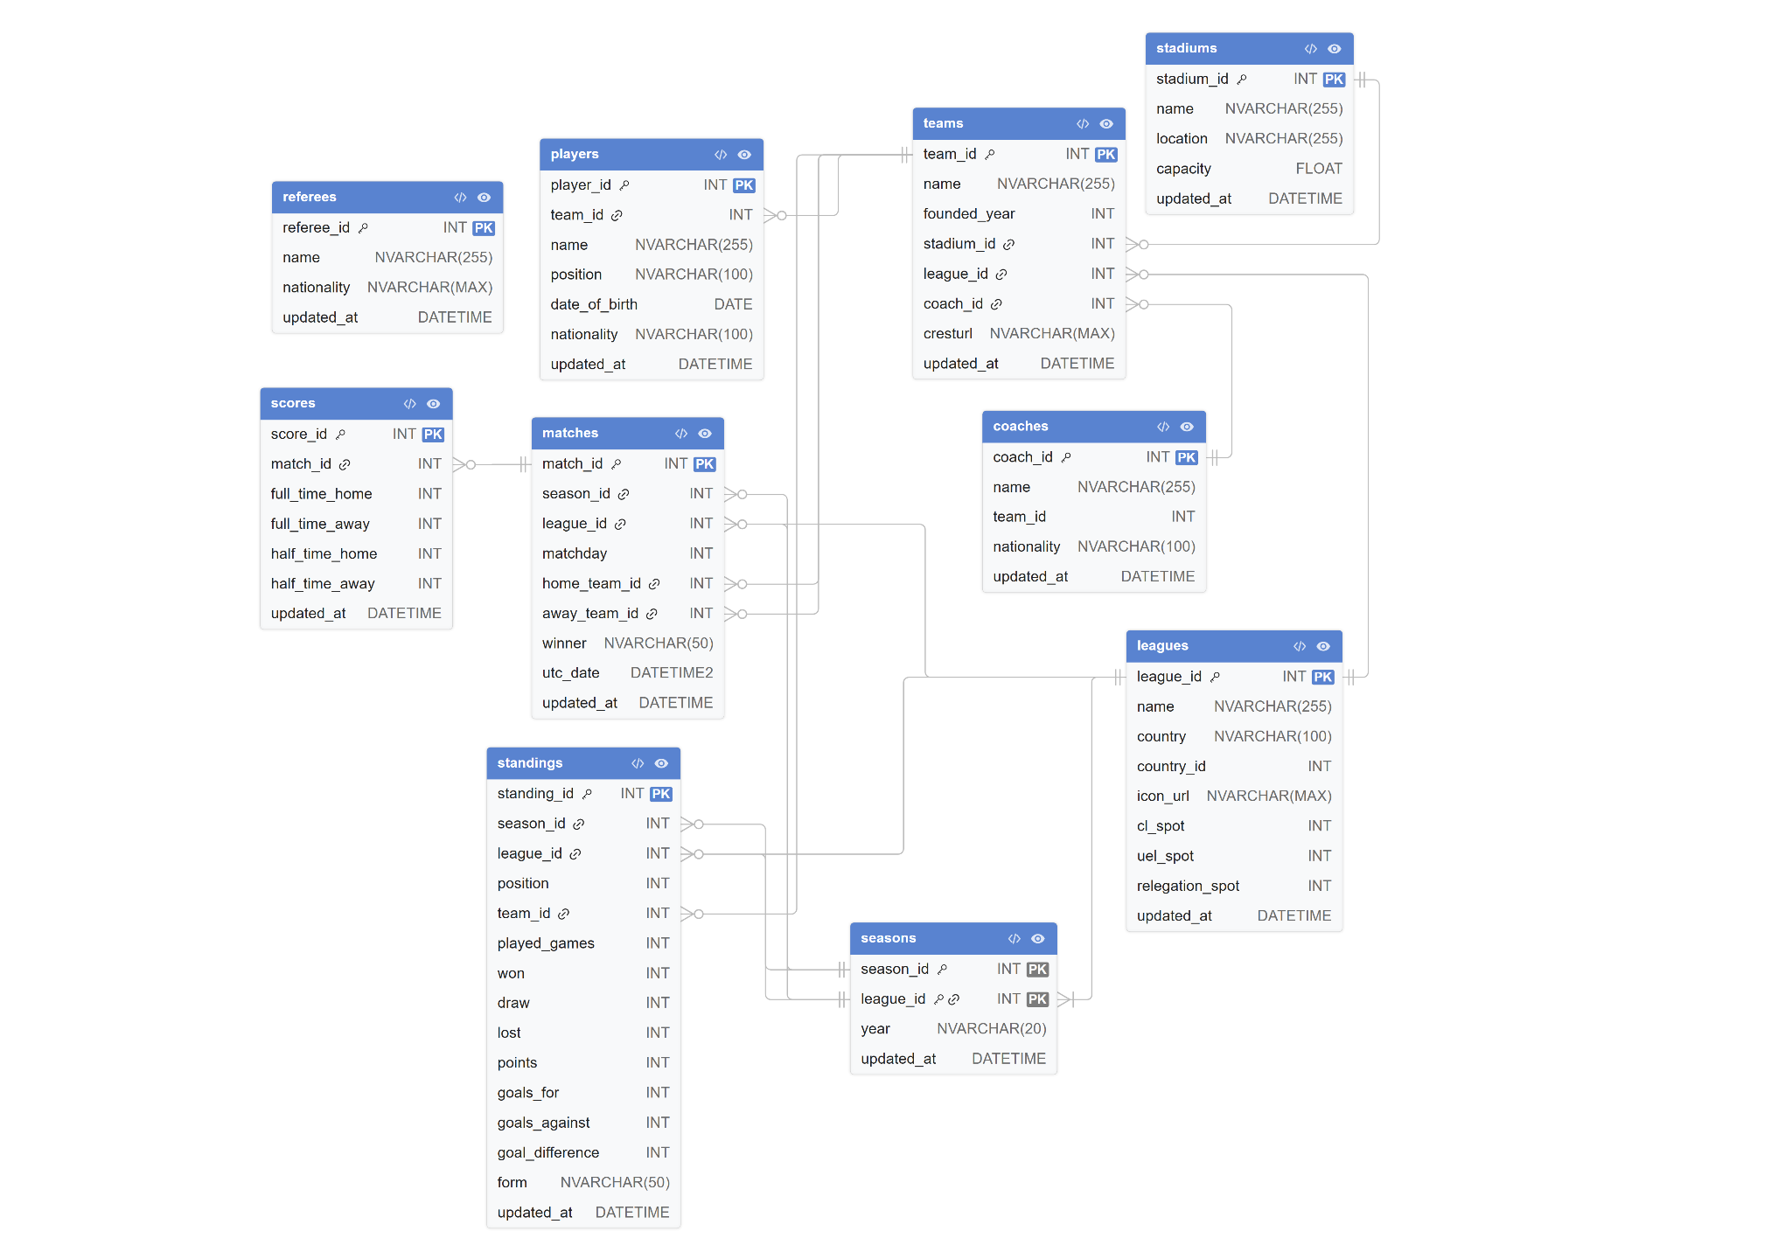

2. Staging Area
The staging area acts as an intermediate layer between the source system and the Data Warehouse.
It is responsible for temporary storage, cleansing, transformation, and integration of extracted data before loading it into the dimensional model.

2.1. STG DDL
CREATE DATABASE European_Football_Leagues_DWH;
GO

ALTER DATABASE European_Football_Leagues_DWH
COLLATE SQL_Latin1_General_CP1_CI_AS;
GO

USE European_Football_Leagues_DWH;
GO

CREATE SCHEMA STG;
GO

CREATE TABLE STG.stadiums (
stadium_id INT,
name NVARCHAR(255),
location NVARCHAR(255),
capacity FLOAT,
updated_at DATETIME
);

CREATE TABLE STG.leagues (
league_id INT,
name NVARCHAR(255),
country NVARCHAR(100),
country_id INT,
updated_at DATETIME
);

CREATE TABLE STG.coaches (
coach_id INT,
name NVARCHAR(255),
team_id INT NULL,
nationality NVARCHAR(100),
updated_at DATETIME
);

CREATE TABLE STG.teams (
team_id INT,
name NVARCHAR(255),
founded_year INT,
stadium_id INT,
league_id INT,
coach_id INT,
updated_at DATETIME
);

CREATE TABLE STG.scoring_junk (
Score_ID INT,
Match_ID INT,

Venue_type NVARCHAR(20),
Full_time_home INT, -- goals scored by home team at full time
Full_time_away INT, -- goals scored by away team at full time
Half_time_home INT, -- goals scored by home team at half time
Half_time_away INT, -- goals scored by away team at half time

Is_comeback_win BIT DEFAULT 0,
Is_lead_blown BIT DEFAULT 0,
Is_clean_sheet BIT DEFAULT 0,
Is_second_half_specialist BIT DEFAULT 0,
Result_type CHAR(1),

updated_at DATETIME
);

CREATE TABLE STG.Fact_Team_Monthly_Stat(
Team_stat_id INT IDENTITY PRIMARY KEY,

Season_key INT, -- DEGNERATE DIM (20232024)
League_key INT,
Month_key INT,
Team_key INT,

Goals_count INT,
Goals_conceded INT,
Goal_difference INT,

Home_wins_count INT,
Away_wins_count INT,
Total_wins_count INT,

Draw_count INT,
Loss_count INT,

Total_matches_played INT,
Points_total INT
);

CREATE TABLE STG.Fact_Scoring_Efficiency(
Scoring_id INT IDENTITY PRIMARY KEY,

Season_key INT, -- DEGNERATE DIM (20232024)
League_key INT,
Match_Date_key INT,
Team_key INT,
Opponent_key INT,

Scoring_junk_key INT,

Goals_1st_half INT,
Goals_2nd_half INT,
Goals_total INT,
Goals_against_total INT
);

CREATE TABLE STG.Fact_Coach_Stadium_Performance(
Performance_id INT IDENTITY PRIMARY KEY,

Season_key INT, -- DEGNERATE DIM (20232024)
Date_key INT,
Match_key INT,
Team_key INT,
Coach_key INT,
Opponent_coach_key INT,
Stadium_key INT,

Is_home_coach BIT,

Points_earned INT,

Goals_scored INT,
Goals_conceded INT,
Goal_difference INT,

Result_type CHAR(1) -- [W, D, L]
);

CREATE TABLE STG.config_table(
table_name VARCHAR(150) PRIMARY KEY,
last_extract_date DATETIME
);

INSERT INTO STG.config_table VALUES
('stadiums', '1900-01-01'),
('leagues', '1900-01-01'),
('teams', '1900-01-01'),
('coaches', '1900-01-01'),
('scores', '1900-01-01');

2.2. STG ERD
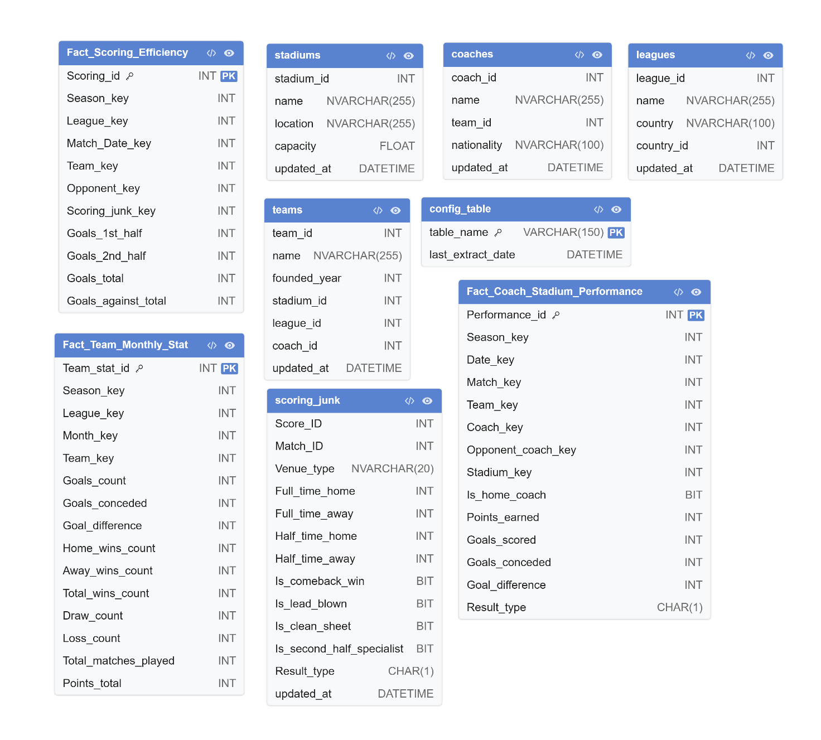

3. Data Warehouse

3.1. Dimensional Model
The data warehouse follows a Star Schema design where fact tables are connected to shared dimensions.
The dimensional model is optimized for analytical queries, KPI calculations, and Power BI reporting.
Dimension Tables
Dimension Table | Description | Type | Key
Dim_Date | Stores full calendar and time attributes for analysis by date, month, quarter, and year | Time Dimension | DateKey
Dim_League | Stores league information such as league name and country | Standard Dimension | League_key
Dim_Team | Stores team details with Slowly Changing Dimension (SCD Type 2) support | SCD Type 2 | Team_key
Dim_Stadium | Stores stadium information with historical tracking support | SCD Type 2 | Stadium_key
Dim_Coach | Stores coach details and nationality information | Standard Dimension | Coach_key
Dim_Scoring_Junk | Junk dimension that stores match behavior flags and categorical indicators | Junk Dimension | Scoring_junk_key
Fact Tables
Fact Table | Grain | Description
Fact_Team_Monthly_Stat | One Team + One League + One Month | Stores aggregated monthly performance statistics for teams
Fact_Scoring_Efficiency | One Team + One Match | Stores detailed scoring and efficiency metrics for every match
Fact_Coach_Stadium_Performance | One Team + One Match | Stores coach and stadium related performance analytics

3.2. Fact Tables
The Data Warehouse contains multiple fact tables designed to support different analytical perspectives related to football performance and competition analysis.

3.2.1. Fact_Team_Monthly_Stats
Section | Details
Grain | One Team + One League + One Month
Source Tables | matches, scores
Dimensions Used | Dim_Team, Dim_League, Dim_Date
Main Purpose | Monthly team performance analytics
Foreign Keys
Fact Column | Dimension | Lookup Condition
Team_Key | Dim_Team | Team_ID = source team_id
League_Key | Dim_League | League_ID = source league_id
Season_Key | Degenerate Dimension | season_year (e.g. 20232024)
Month_Key | Dim_Date | First day of month from utc_date
Measures
Measure | Source | Calculation
Goals_Count | scores | SUM(full_time_home / full_time_away)
Home_Wins_Count | matches | winner = 'HOME_TEAM'
Away_Wins_Count | matches | winner = 'AWAY_TEAM'
Total_Wins_Count | Calculated | Home + Away wins
Total_Matches_Played | matches | COUNT(match_id)
Draw_Count | matches | winner = 'DRAW'
Loss_Count | Calculated | Matches - Wins - Draws
Goals_Conceded | scores | Opponent goals
Goal_Difference | Calculated | Goals_Count - Goals_Conceded
Points_Total | Calculated | Win=3, Draw=1, Loss=0

ETL Flow
Step | Action
1 | Read matches + scores
2 | Generate Home & Away rows
3 | Calculate KPIs
4 | Group by Team + League + Month + Season
5 | Lookup Dimension Keys
6 | Insert into Fact_Team_Monthly_Stats

3.2.2. Fact_Scoring_Efficiency
Section | Details
Grain | One Team + One Match
Source Tables | matches, scores
Dimensions Used | Dim_Team, Dim_League, Dim_Date, Dim_Scoring_Junk
Main Purpose | Scoring efficiency & match analysis
Foreign Keys
Fact Column | Dimension | Lookup Condition
Team_Key | Dim_Team | Team_ID = current team
Opponent_Key | Dim_Team | Team_ID = opponent team
League_Key | Dim_League | League_ID = source league_id
Season_Key | Degenerate Dimension | season_year (e.g. 20232024)
Season_Key | Dim_Season | Season_ID = source season_id
Match_Date_Key | Dim_Date | utc_date
Scoring_Junk_Key | Dim_Scoring_Junk | Matching junk flag combination
Measures
Measure | Source | Calculation
Goals_1st_Half | scores | half_time_home / half_time_away
Goals_2nd_Half | scores | full_time - half_time
Goals_Total | scores | full_time_home / full_time_away
Goals_Against_Total | scores | Opponent full time goals

Junk Dimension Flags
Flag | Logic
Venue_Type | Home / Away
Is_Comeback_Win | Losing halftime AND won fulltime
Is_Lead_Blown | Winning halftime AND did not win final
Is_Clean_Sheet | Opponent goals = 0
Is_Second_Half_Specialist | 2nd half goals > 1st half goals
Result_Type | W / D / L
ETL Flow
Step | Action
1 | Read matches + scores
2 | Create Home Team row
3 | Create Away Team row
4 | Calculate goals metrics
5 | Calculate junk flags
6 | Lookup dimension surrogate keys
7 | Insert into Fact_Scoring_Efficiency

3.2.3. Fact_Coach_Stadium_Performance
Section | Details
Grain | One Team + One Match
Source Tables | matches, scores, teams, stadiums, coach history
Dimensions Used | Dim_Team, Dim_Coach, Dim_Stadium, Dim_League, Dim_Date
Main Purpose | Coach and stadium performance analytics
Foreign Keys
Fact Column | Dimension | Lookup Condition
Match_Key | Degenerate Dimension | Source Match_id
Team_Key | Dim_Team | Team_ID = current team
Coach_Key | Dim_Coach | Active coach during match date
Opponent_Coach_Key | Dim_Coach | Opponent active coach
Stadium_Key | Dim_Stadium | Stadium_ID = source stadium_id
League_Key | Dim_League | League_ID = source league_id
Season_Key | Degenerate Dimension | season_year (e.g. 20232024)
Date_Key | Dim_Date | utc_date
Measures
Measure | Source | Calculation
Points_Earned | Calculated | Win=3, Draw=1, Loss=0
Goals_Scored | scores | Team full time goals
Goals_Conceded | scores | Opponent full time goals
Goal_Difference | Calculated | Goals_Scored - Goals_Conceded
Result_type | Calculated | W / D / L
Is_Home_Coach | matches | Team = home_team_id

ETL Flow
Step | Action
1 | Read matches + scores
2 | Find active coach from bridge table
3 | Generate Home Team row
4 | Generate Away Team row
5 | Calculate performance KPIs
6 | Lookup surrogate keys
7 | Insert into Fact_Coach_Stadium_Performance

3.3. DWH DDL
USE European_Football_Leagues_DWH;
GO

CREATE SCHEMA DWH;
GO

CREATE TABLE DWH.Dim_Date (
[DateKey] [int] NOT NULL,
[Date] [date] NOT NULL,
[Day] [tinyint] NOT NULL,
[DaySuffix] [char](2) NOT NULL,
[Weekday] [tinyint] NOT NULL,
[WeekDayName] [varchar](10) NOT NULL,
[WeekDayName_Short] [char](3) NOT NULL,
[WeekDayName_FirstLetter] [char](1) NOT NULL,
[DOWInMonth] [tinyint] NOT NULL,
[DayOfYear] [smallint] NOT NULL,
[WeekOfMonth] [tinyint] NOT NULL,
[WeekOfYear] [tinyint] NOT NULL,
[Month] [tinyint] NOT NULL,
[MonthName] [varchar](10) NOT NULL,
[MonthName_Short] [char](3) NOT NULL,
[MonthName_FirstLetter] [char](1) NOT NULL,
[Quarter] [tinyint] NOT NULL,
[QuarterName] [varchar](6) NOT NULL,
[Year] [int] NOT NULL,
[MMYYYY] [char](6) NOT NULL,
[MonthYear] [char](7) NOT NULL,
[IsWeekend] BIT NOT NULL,
[IsHoliday] BIT NOT NULL,
[HolidayName] VARCHAR(20) NULL,
[SpecialDays] VARCHAR(20) NULL,
[FirstDateofYear] DATE NULL,
[LastDateofYear] DATE NULL,
[FirstDateofQuater] DATE NULL,
[LastDateofQuater] DATE NULL,
[FirstDateofMonth] DATE NULL,
[LastDateofMonth] DATE NULL,
[FirstDateofWeek] DATE NULL,
[LastDateofWeek] DATE NULL,
[CurrentYear] SMALLINT NULL,
[CurrentQuater] SMALLINT NULL,
[CurrentMonth] SMALLINT NULL,
[CurrentWeek] SMALLINT NULL,
[CurrentDay] SMALLINT NULL,
PRIMARY KEY CLUSTERED ([DateKey] ASC)
);

CREATE TABLE DWH.Dim_League (
League_key INT IDENTITY PRIMARY KEY,
League_id INT,
Name NVARCHAR(255),
Country NVARCHAR(100)
);

CREATE TABLE DWH.Dim_Team (
Team_key INT IDENTITY PRIMARY KEY,
Team_id INT,
Name NVARCHAR(255),
Founded_year INT,
Start_date DATETIME,
End_date DATETIME,
Current_flag BIT
);

CREATE TABLE DWH.Dim_Stadium (
Stadium_key INT IDENTITY PRIMARY KEY,
Stadium_id INT,
Name NVARCHAR(255),
Location NVARCHAR(255),
Capacity FLOAT,
Start_date DATETIME,
End_date DATETIME,
Current_flag BIT
);

CREATE TABLE DWH.Dim_Coach (
Coach_key INT IDENTITY PRIMARY KEY,
Coach_id INT,
Name NVARCHAR(255),
Nationality NVARCHAR(100)
);

CREATE TABLE DWH.Dim_Scoring_Junk (
Scoring_junk_key INT IDENTITY PRIMARY KEY,
Venue_type NVARCHAR(20),
Is_comeback_win BIT,
Is_lead_blown BIT,
Is_clean_sheet BIT,
Is_second_half_specialist BIT,
Result_type CHAR(1)
);

CREATE TABLE DWH.Fact_Team_Monthly_Stat(
Fact_team_stat_key INT IDENTITY PRIMARY KEY,

Season_key INT, -- DEGNERATE DIM (20232024)
League_key INT,
Month_key INT,
Team_key INT,

Goals_count INT,
Goals_conceded INT,
Goal_difference INT,

Home_wins_count INT,
Away_wins_count INT,
Total_wins_count INT,

Draw_count INT,
Loss_count INT,

Total_matches_played INT,
Points_total INT,

FOREIGN KEY (Month_key) REFERENCES DWH.Dim_Date(DateKey),
FOREIGN KEY (League_key) REFERENCES DWH.Dim_League(League_key),
FOREIGN KEY (Team_key) REFERENCES DWH.Dim_Team(Team_key)
);

CREATE TABLE DWH.Fact_Scoring_Efficiency(
Fact_scoring_key INT IDENTITY PRIMARY KEY,

Season_key INT, -- DEGNERATE DIM (20232024)
League_key INT,
Date_key INT,
Team_key INT,
Opponent_key INT,

Scoring_junk_key INT,

Goals_1st_half INT,
Goals_2nd_half INT,
Goals_total INT,
Goals_against_total INT,

FOREIGN KEY (Date_key) REFERENCES DWH.Dim_Date(DateKey),
FOREIGN KEY (League_key) REFERENCES DWH.Dim_League(League_key),
FOREIGN KEY (Team_key) REFERENCES DWH.Dim_Team(Team_key),
FOREIGN KEY (Opponent_key) REFERENCES DWH.Dim_Team(Team_key),
FOREIGN KEY (Scoring_junk_key) REFERENCES DWH.Dim_Scoring_Junk(Scoring_junk_key)
);

CREATE TABLE DWH.Fact_Coach_Stadium_Performance(
Fact_performance_key INT IDENTITY PRIMARY KEY,

Season_key INT, -- DEGNERATE DIM (20232024)
Match_key INT,
Team_key INT,
Coach_key INT,
Opponent_coach_key INT,
Stadium_key INT,
Date_key INT,

Is_home_coach BIT,

Points_earned INT,

Goals_scored INT,
Goals_conceded INT,
Goal_difference INT,

Result_type CHAR(1), -- [W, D, L]

FOREIGN KEY (Date_key) REFERENCES DWH.Dim_Date(DateKey),
FOREIGN KEY (Team_key) REFERENCES DWH.Dim_Team(Team_key),
FOREIGN KEY (Coach_key) REFERENCES DWH.Dim_Coach(Coach_key),
FOREIGN KEY (Opponent_coach_key) REFERENCES DWH.Dim_Coach(Coach_key),
FOREIGN KEY (Stadium_key) REFERENCES DWH.Dim_Stadium(Stadium_key)
);

3.4. DWH ERD
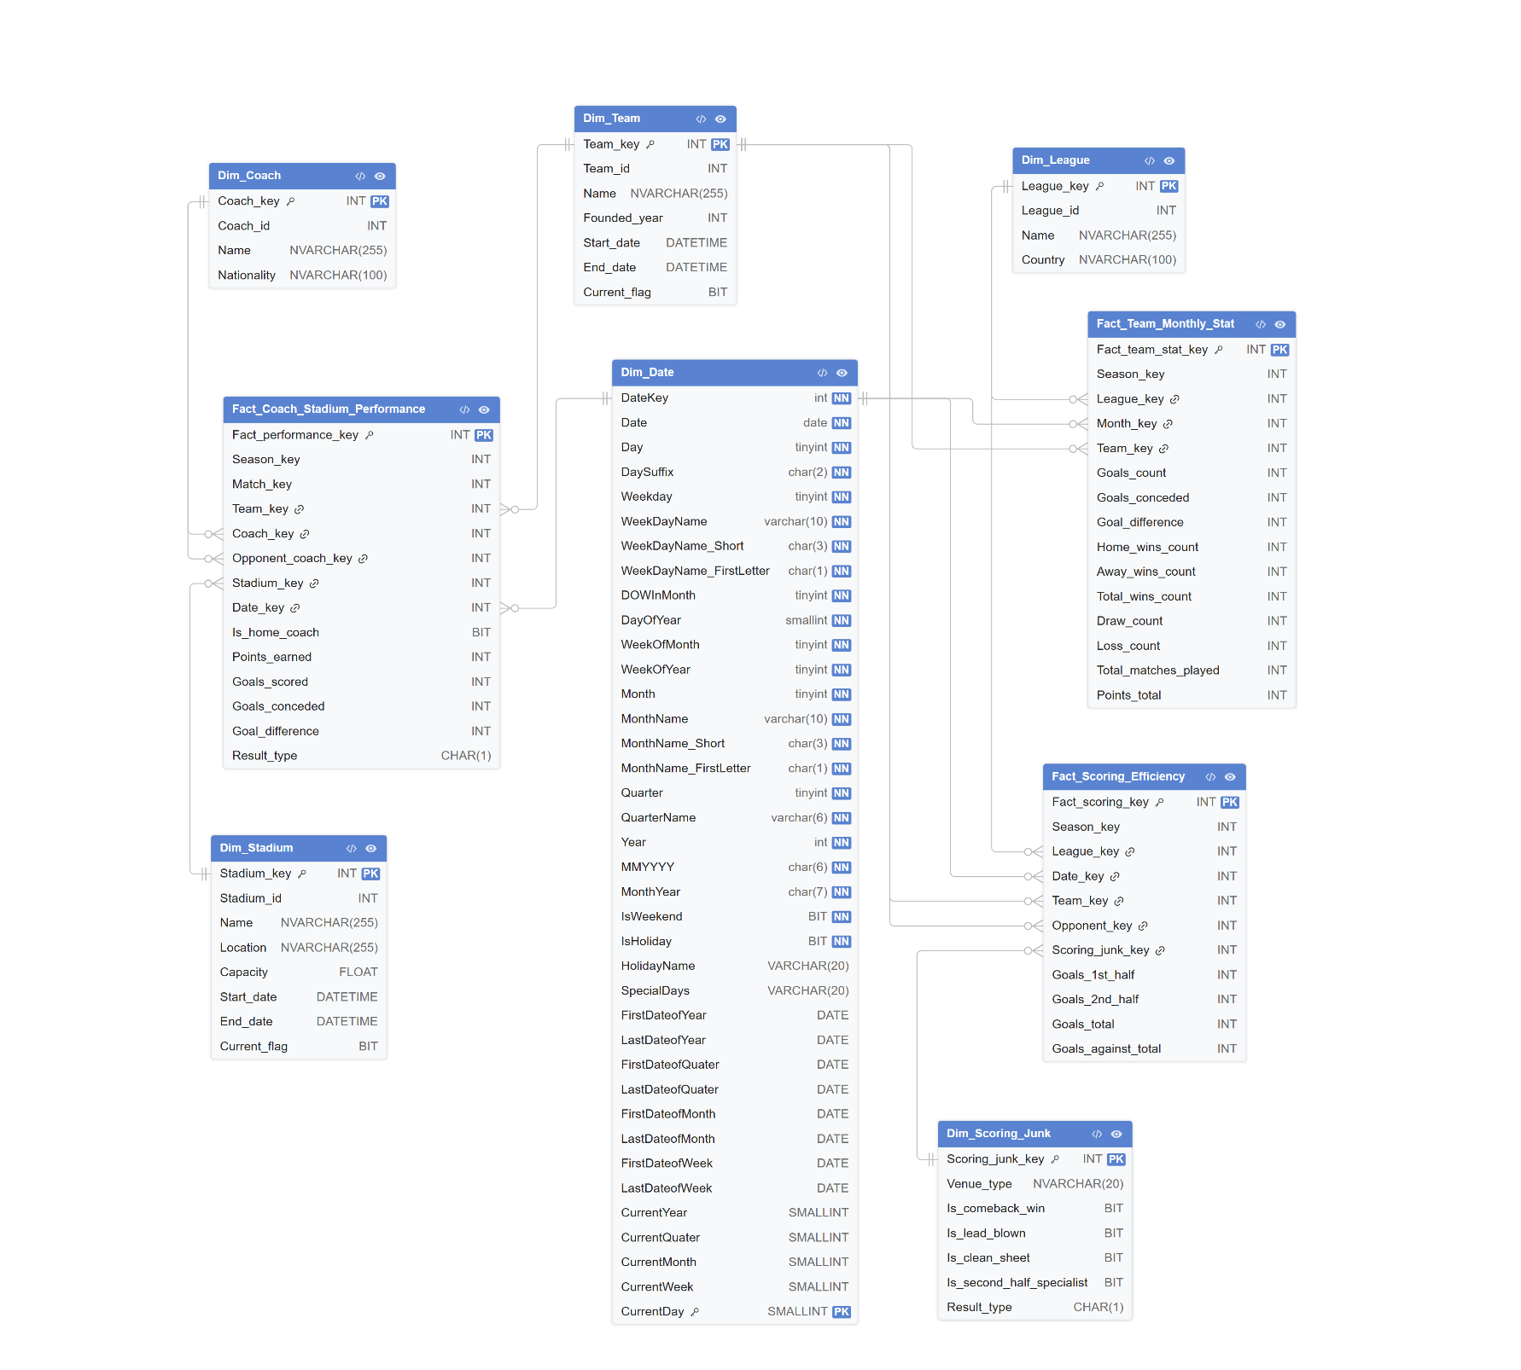

4. ETL Process

4.1. ETL Architecture
The ETL process follows a three-layer architecture:
- Source Database (OLTP)
- Staging Area (STG)
- Data Warehouse (DWH)
The source system contains normalized operational football data such as teams, matches, leagues, coaches, and scores. Data is extracted from the source database and loaded into the staging area for cleaning and transformation before loading into the dimensional warehouse.
ETL Workflow
Source Database → STG Tables → Dimension Tables → Fact Tables → Power BI
The ETL pipeline was implemented using SQL Server Integration Services (SSIS).

4.2. Extraction Phase
During the extraction phase, data is collected from the source OLTP database.
Extraction Features
Feature | Description
Source System | European_Football_Leagues
Extraction Type | Incremental Load
Extraction Tool | SSIS
Change Tracking | updated_at column
Metadata Tracking | STG.config_table
Incremental Loading Strategy
The ETL process uses the updated_at column to extract only new or modified records.
The STG.config_table stores the last successful extraction date for each table.
Example:
SELECT *
FROM teams
WHERE updated_at > @LastExtractDate;
This strategy improves performance and reduces ETL execution time.

4.3. Transformation Phase
The transformation phase prepares data for analytical processing.
Main Transformations
Transformation | Description
Data Cleaning | Remove NULLs and invalid values
Data Standardization | Normalize text and formats
KPI Calculations | Calculate goals, points, wins, losses
Aggregation | Monthly team statistics aggregation
Derived Columns | Goal difference and result type
Lookup Operations | Generate surrogate keys
SCD Type 2 | Historical tracking for dimensions
Junk Dimension Generation | Match behavior flags

4.4. Loading Phase
After transformations are completed, data is loaded into the warehouse.
Loading Order:
- Dimention Tables
- Junk Dimention
- Fact Tables
Dimension Loading: Dimensions are loaded first to ensure surrogate keys are available for fact tables.
Fact Table Loading: Fact tables are populated after performing lookup operations to retrieve surrogate keys from dimensions.
Error Handling
- Lookup error redirection
- Duplicate prevention
- NULL handling
- Data validation
- SSIS logging

4.5. ETL Workflow Steps
- Extract source data
- Load data into STG tables
- Clean and transform data
- Populate dimension tables
- Populate fact tables
- Update config table

4.6. Incremental Load Process
The warehouse supports incremental refreshes.
Benefits
- Faster ETL execution
- Reduced server load
- Improved scalability
- Better scheduling efficiency
Incremental Load Logic
WHERE updated_at > last_extract_date
The extraction date is updated after each successful ETL execution.

4.7. SSIS Control / Data Flow Screenshots

4.7.1. Load Dim_Coach
Control Flow | Data Flow
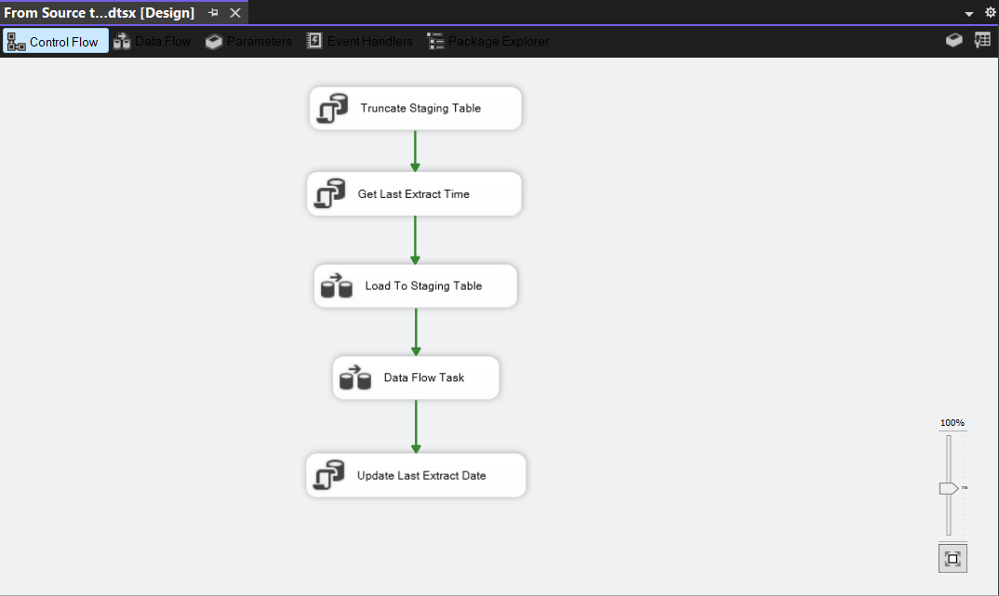 | 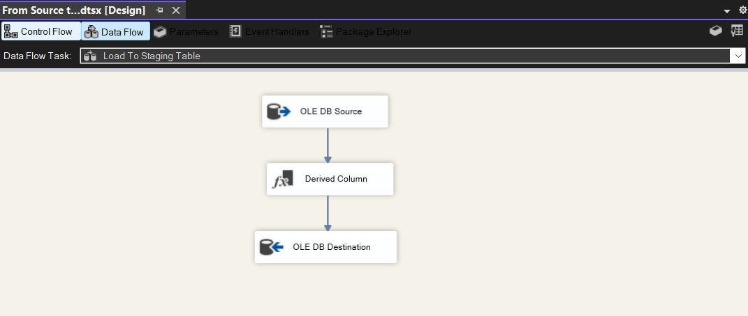  Load to STG
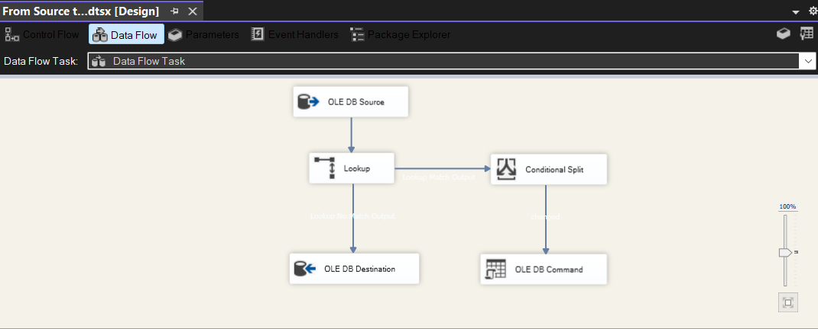
Load to DWH

4.7.2. Load Dim_Leagues
Control Flow | Data Flow
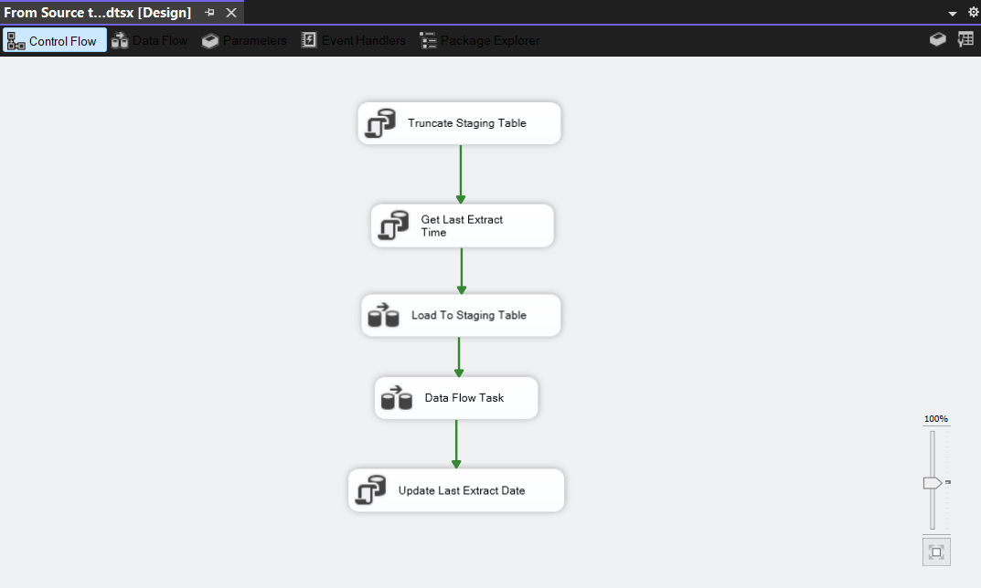 | 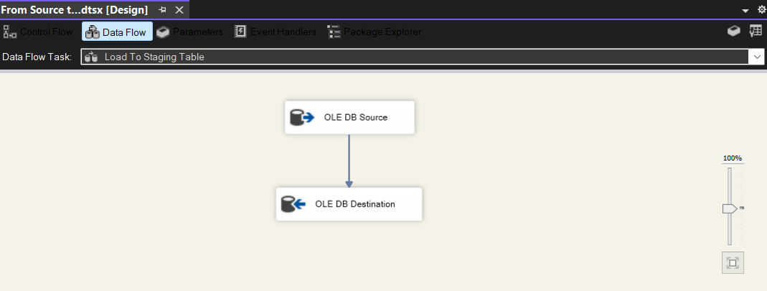  Load to STG
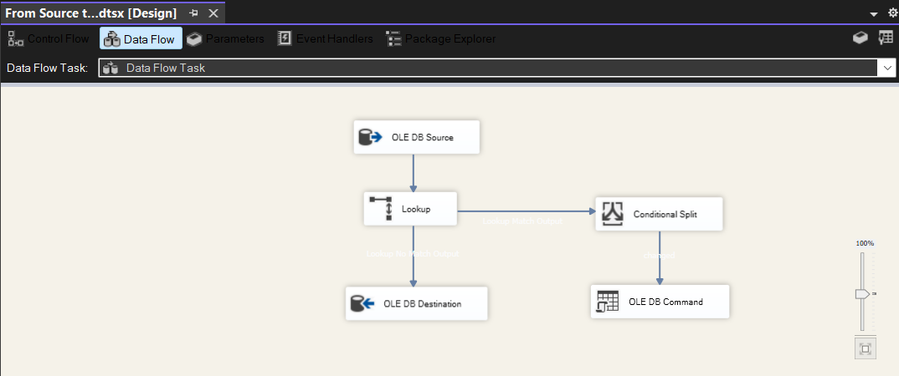
Load to DWH

4.7.3. Load Dim_Score_junk
Control Flow | Data Flow
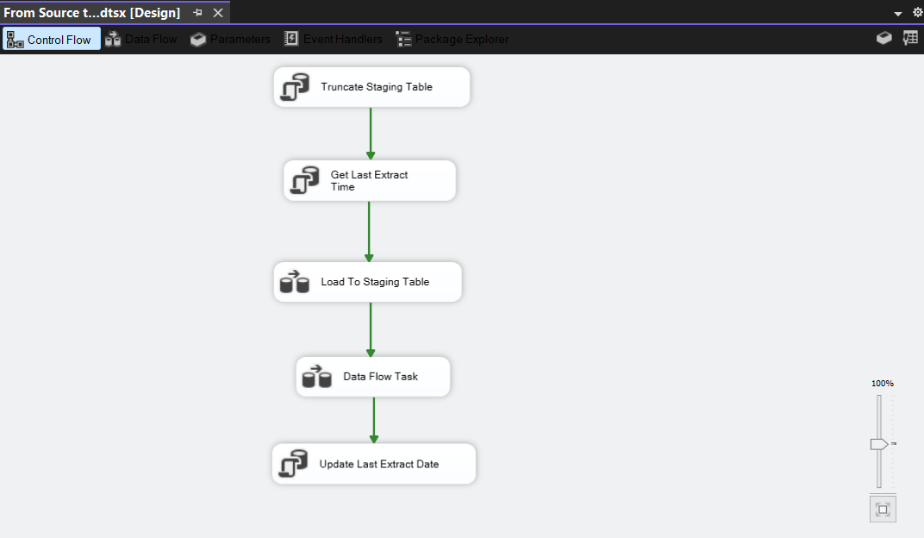 | 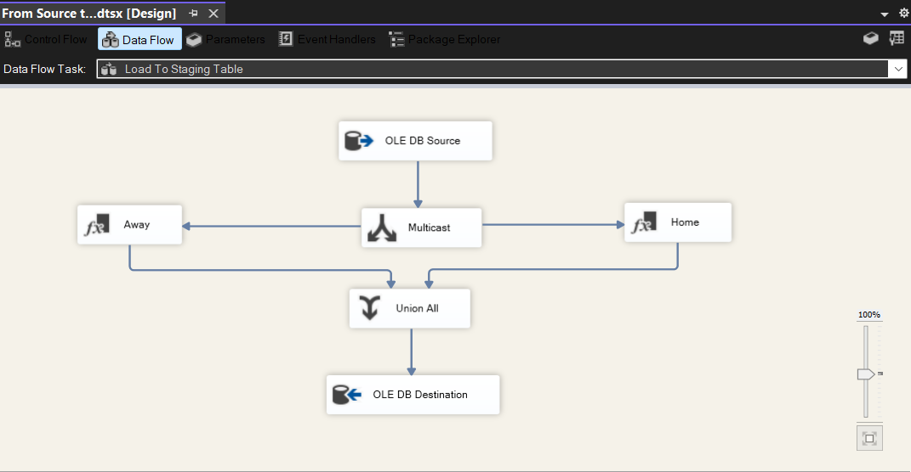  Load to STG
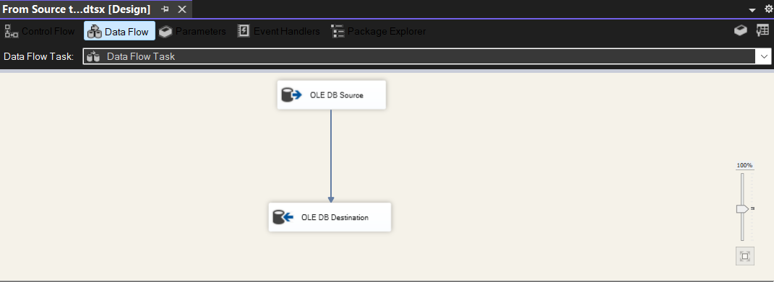
Load to DWH

4.7.4. Load Dim_Stadium
Control Flow | Data Flow
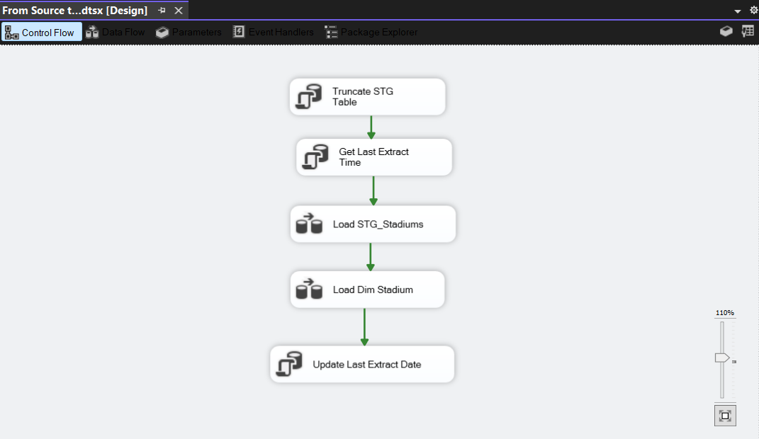 | 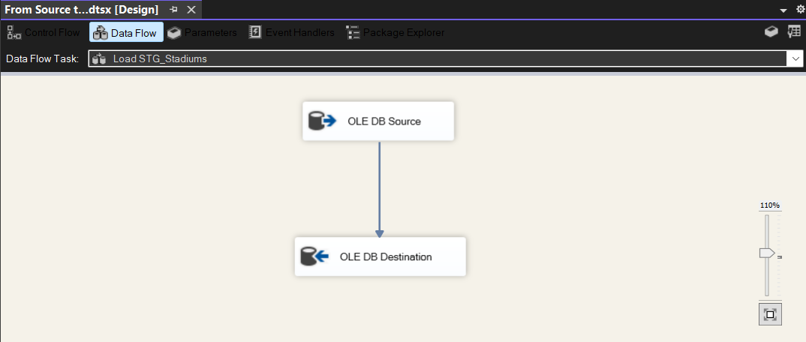  Load to STG
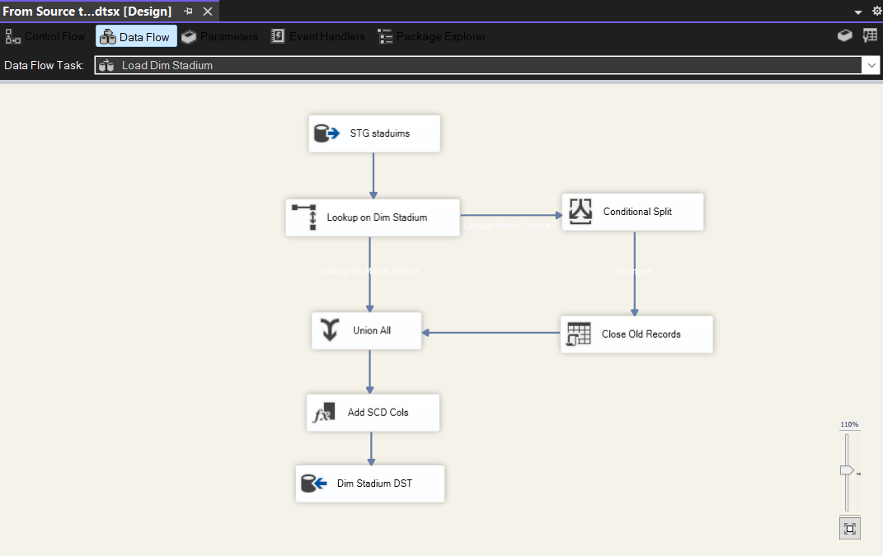
Load to DWH

4.7.5. Load Dim_Team
Control Flow | Data Flow
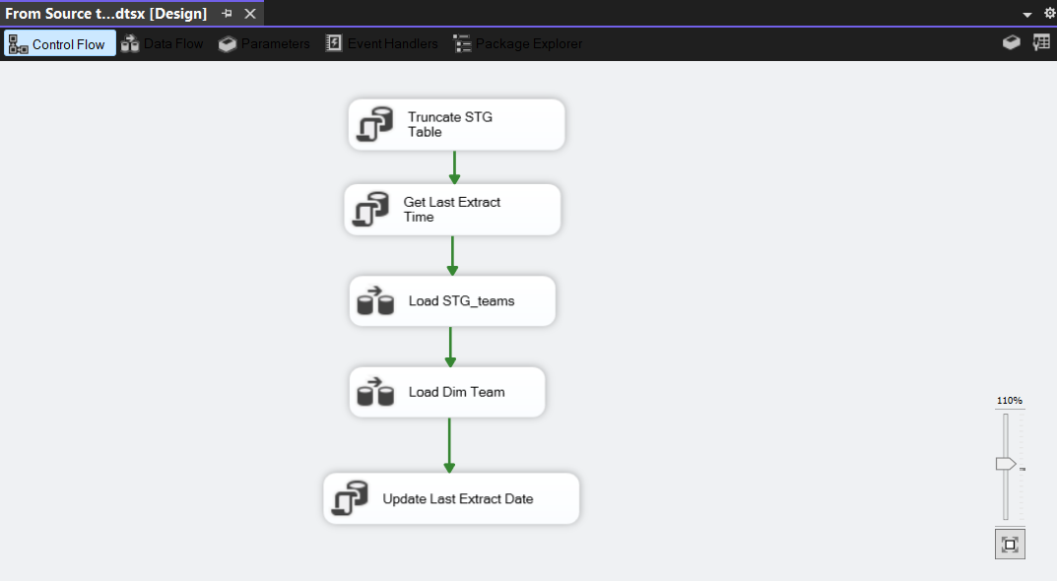 | 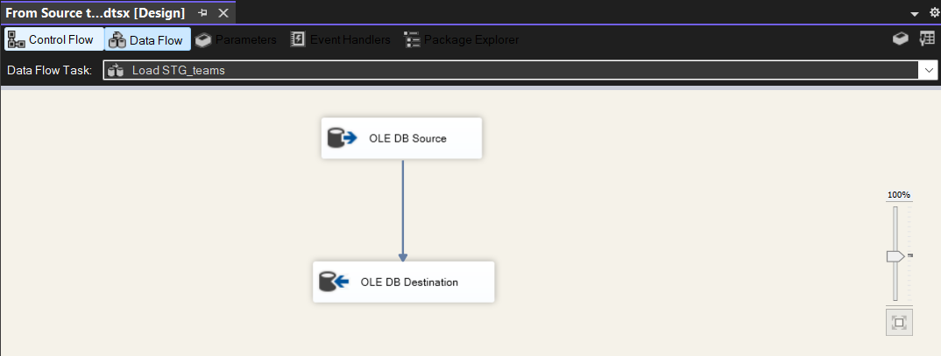  Load to STG
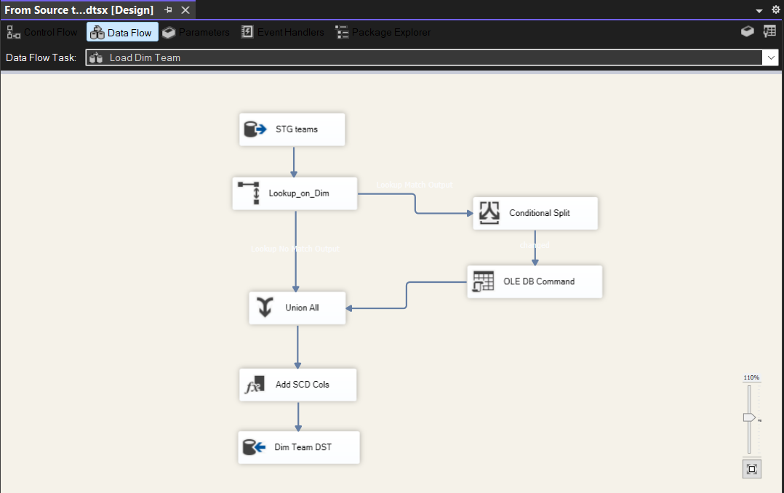
Load to DWH

4.7.6. Load Fact_Team_Monthly_Stat
Control Flow | Data Flow
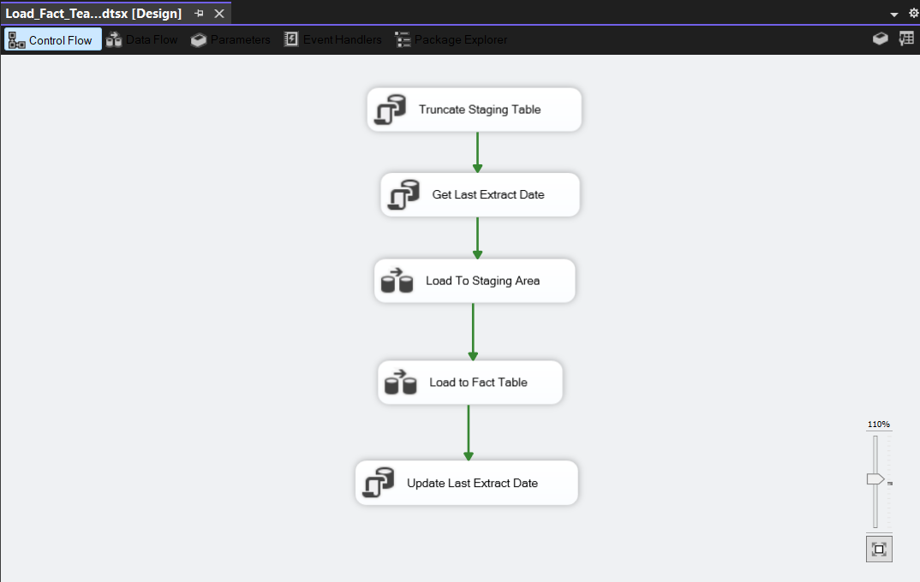 | 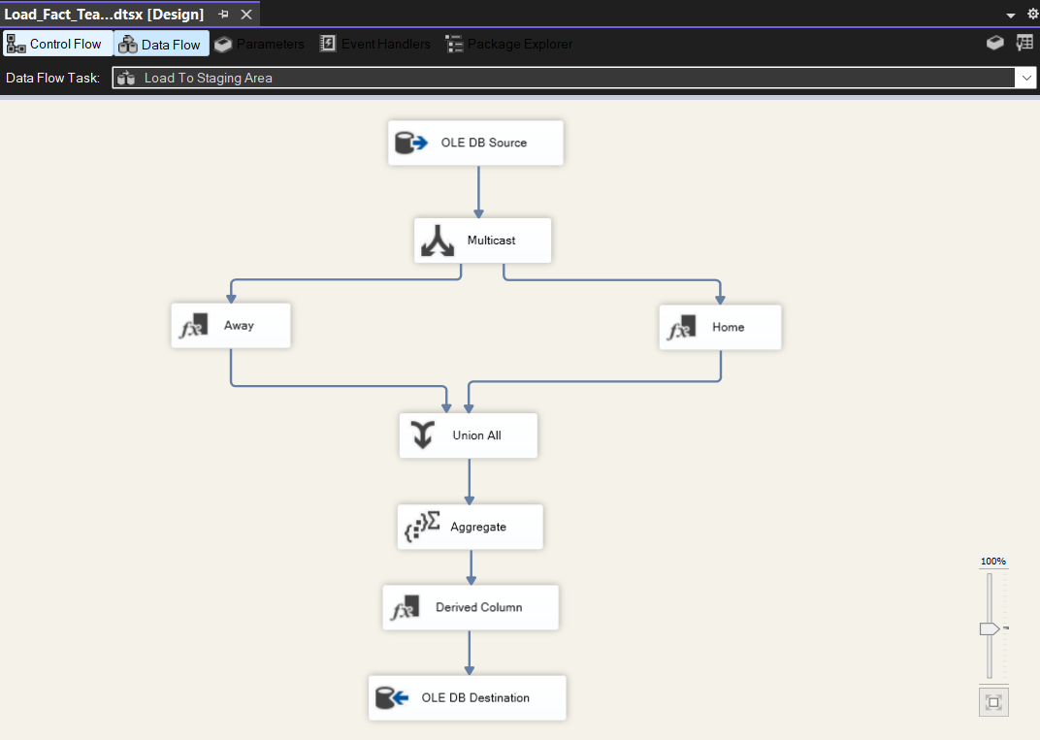  Load to STG
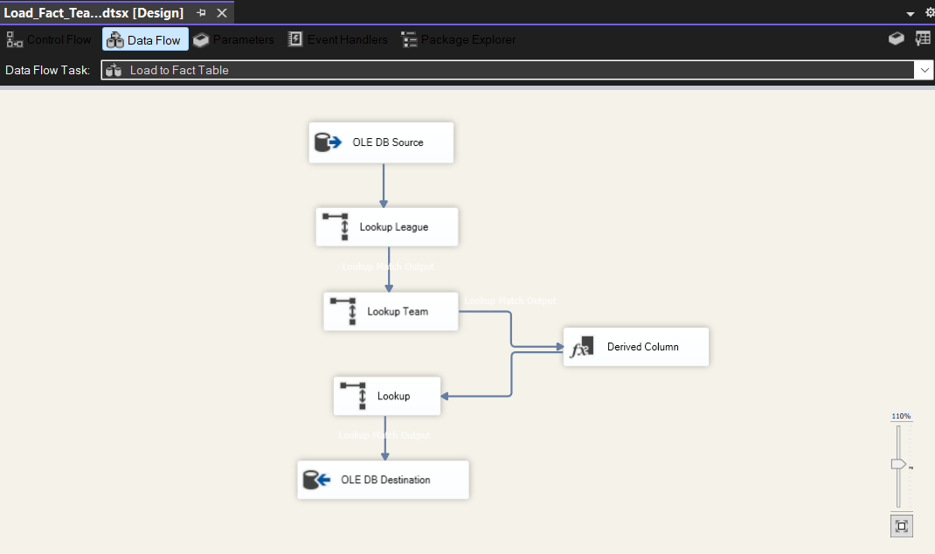
Load to DWH

4.7.7. Load Fact_Scoring_Efficiency
Control Flow | Data Flow
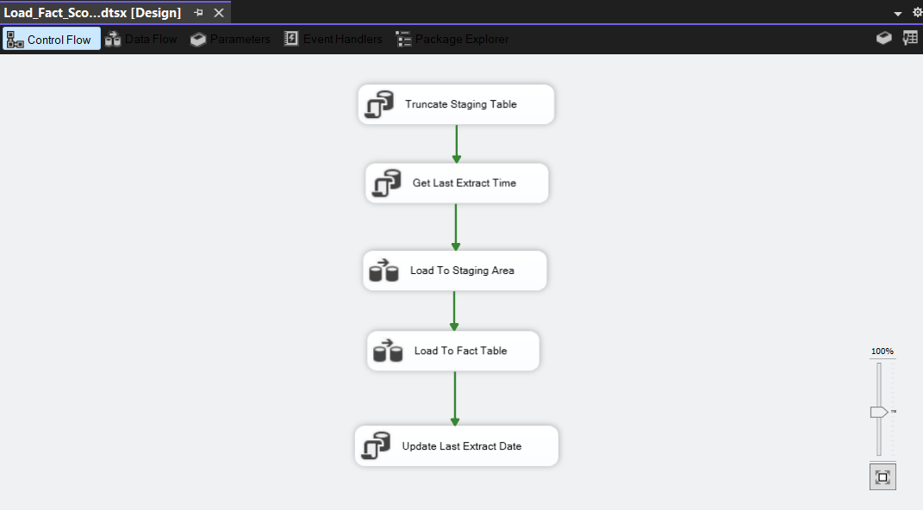 | 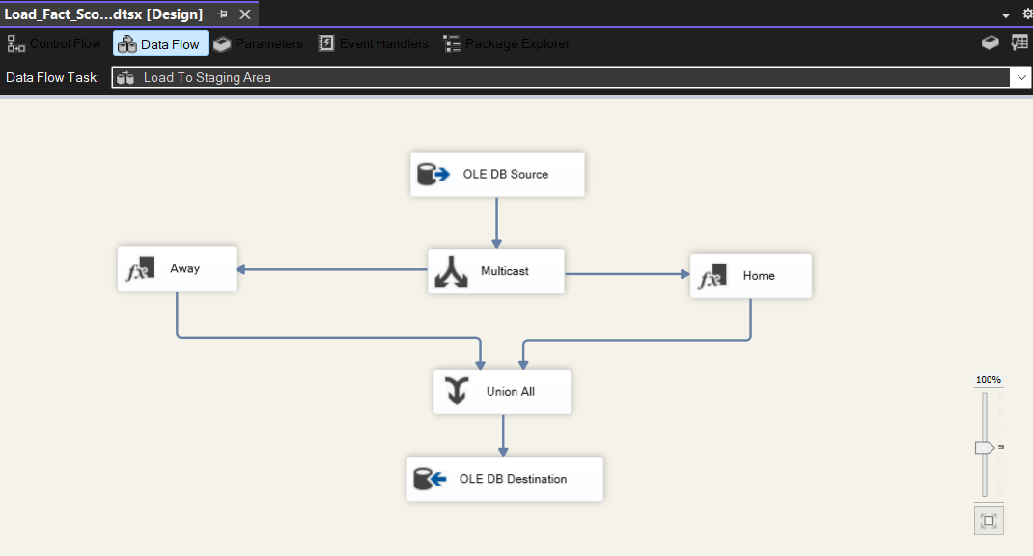  Load to STG
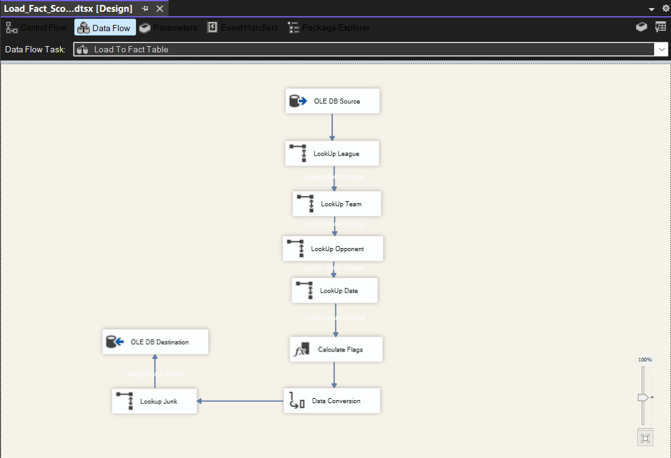
Load to DWH

4.7.8. Load Fact_Coach_Stadium_Performance
Control Flow | Data Flow
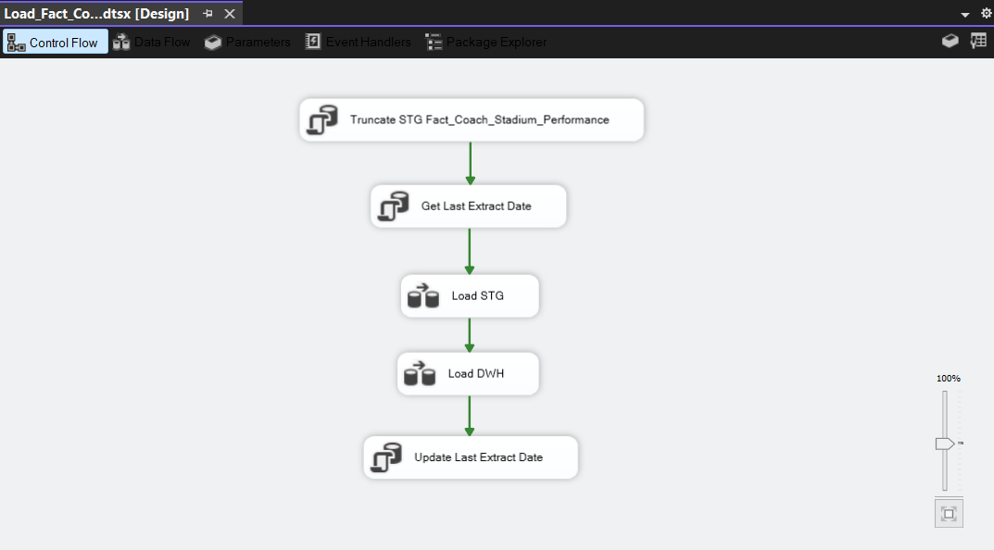 | 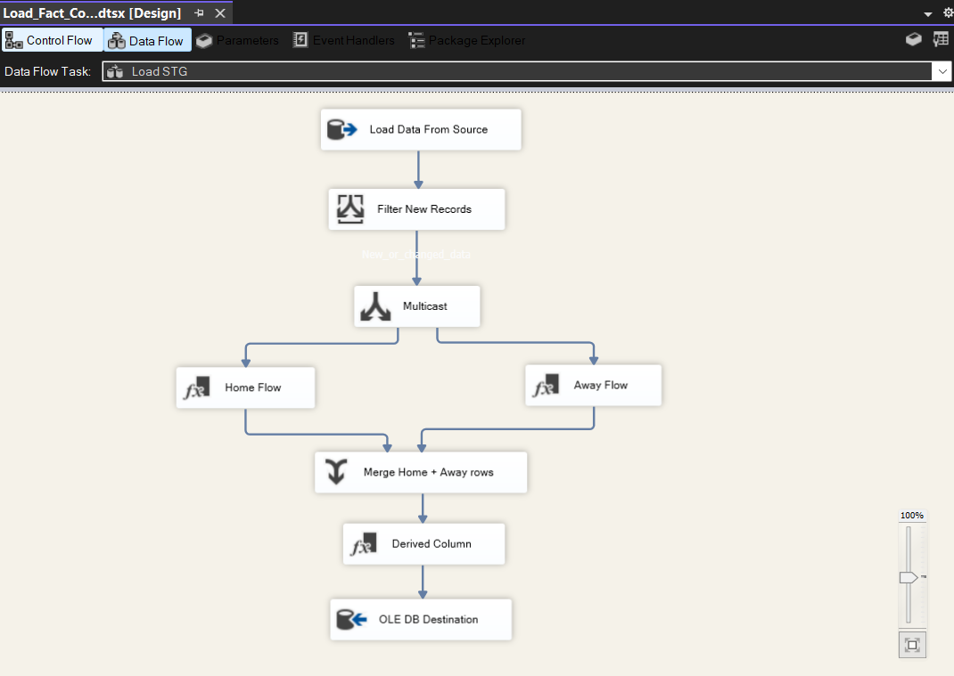  Load to STG
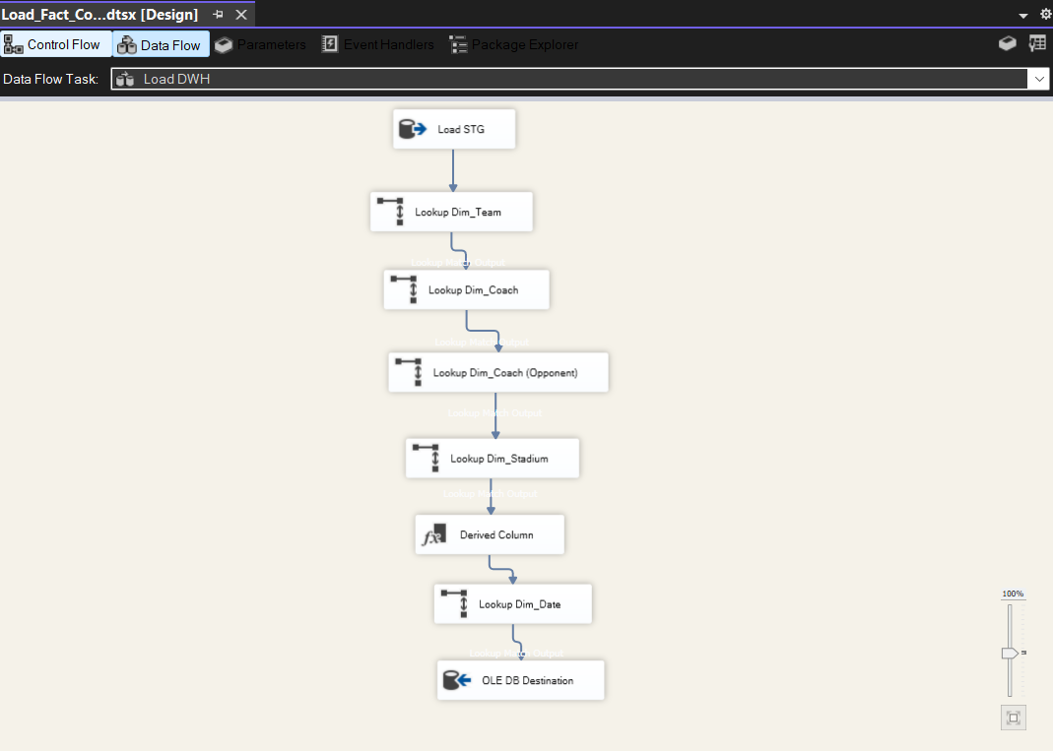
Load to DWH

5. KPIs

5.1. Team Performance KPIs (Season / League / Team Level)
KPI | Definition | Scope | Fact Table
1. Total Points | مجموع النقاط | Team + Season + League | Fact_Team_Monthly_Stat
2. Total Wins | عدد الانتصارات | Team + Season | Fact_Team_Monthly_Stat
3. Total Draws | عدد التعادلات | Team + Season | Fact_Team_Monthly_Stat
4. Total Losses | عدد الهزائم | Team + Season | Fact_Team_Monthly_Stat
5. Goals Scored | إجمالي الأهداف | Team + Season | Both Facts
6. Goals Conceded | أهداف مستقبلة | Team + Season | Both Facts
7. Goal Difference | فرق الأهداف | Team + Season | Both Facts
8. Matches Played | عدد المباريات | Team + Season | Fact_Team_Monthly_Stat
9. Win Rate | نسبة الفوز | Team + Season | Derived
10. Points per Match | متوسط النقاط | Team + Season | Derived

5.2. League Level KPIs (League + Season)
KPI | Definition | Scope | Fact Table
11. Total League Goals | إجمالي أهداف الدوري | League + Season | Fact_Team_Monthly_Stat
12. Average Goals per Match | متوسط الأهداف | League + Season | Derived
13. Total Matches | عدد مباريات الدوري | League + Season | Fact_Team_Monthly_Stat
14. Average Points per Team | متوسط النقاط لكل فريق | League + Season | Derived
15. Competitive Balance Index | توازن الدوري | League + Season | Derived
16. Home Advantage Ratio | أفضلية الأرض | League + Season | Fact_Team_Monthly_Stat

5.3. Match Performance KPIs (Match + Date Level)
KPI | Definition | Scope | Fact Table
17. Total Goals per Match | أهداف المباراة | Match + Date | Fact_Scoring_Efficiency
18. First Half Goals | أهداف الشوط الأول | Match | Fact_Scoring_Efficiency
19. Second Half Goals | أهداف الشوط الثاني | Match | Fact_Scoring_Efficiency
20. Comeback Matches Count | مباريات العودة | Season + Date | Dim_Scoring_Junk
21. Clean Sheet Matches | مباريات بدون أهداف | Season | Dim_Scoring_Junk
22. Draw Rate | نسبة التعادل | Season + League | Fact_Team_Monthly_Stat

5.4. Team Form & Momentum KPIs
KPI | Definition | Scope | Fact Table
23. Last 5 Matches Form Score | آخر 5 مباريات | Team + Season | standings.form
24. Winning Streak | أطول سلسلة انتصارات | Team + Season | Derived
25. Losing Streak | أطول سلسلة خسائر | Team + Season | Derived
26. Monthly Performance Trend | الأداء الشهري | Team + Season + Month | Fact_Team_Monthly_Stat

5.5. Coach & Stadium KPIs
KPI | Definition | Scope | Fact Table
27. Coach Win Rate | نسبة فوز المدرب | Coach + Season | Fact_Coach_Stadium_Performance
28. Coach Points per Match | نقاط لكل مباراة | Coach + Season | Fact_Coach_Stadium_Performance
29. Home Stadium Win Rate | نسبة الفوز في ملعب الفريق | Stadium + Team | Fact_Coach_Stadium_Performance
30. Coach Impact Score | تأثير المدرب على الأداء | Coach + Team + Season | Derived

6. SSIS Packages & Scheduling Screenshots

6.1. Schedule Packages Screenshots
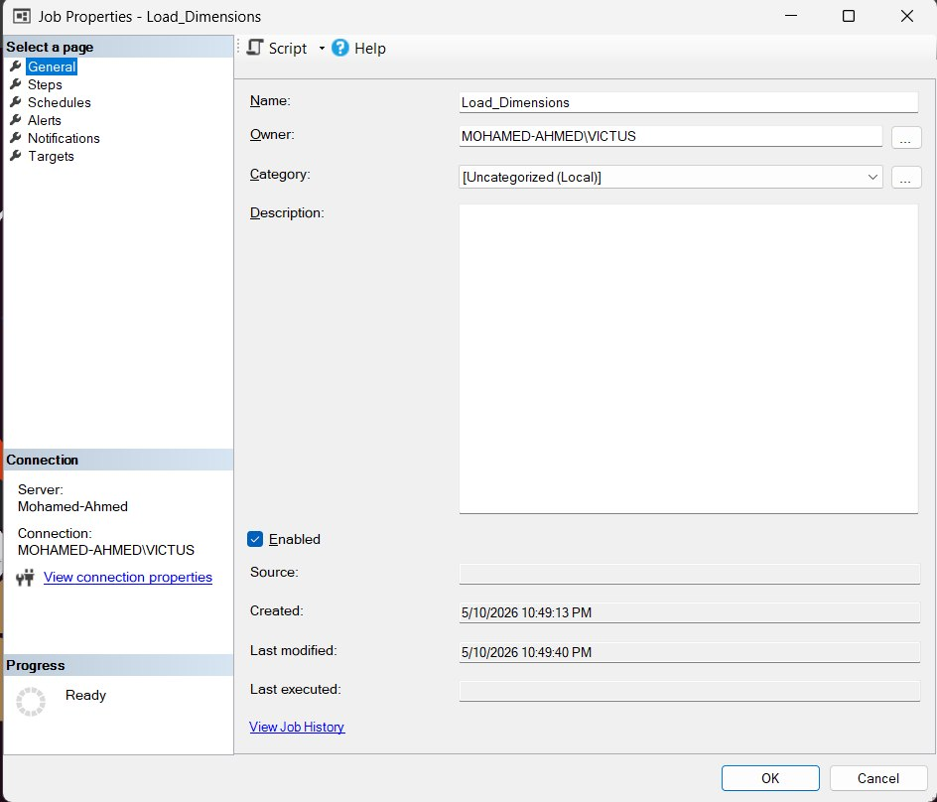  Fig. 6.1.1 | 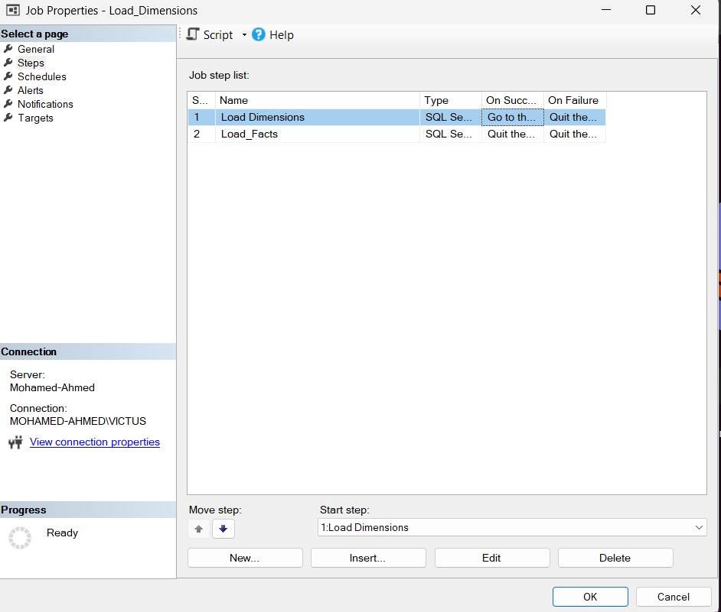  Fig. 6.1.2
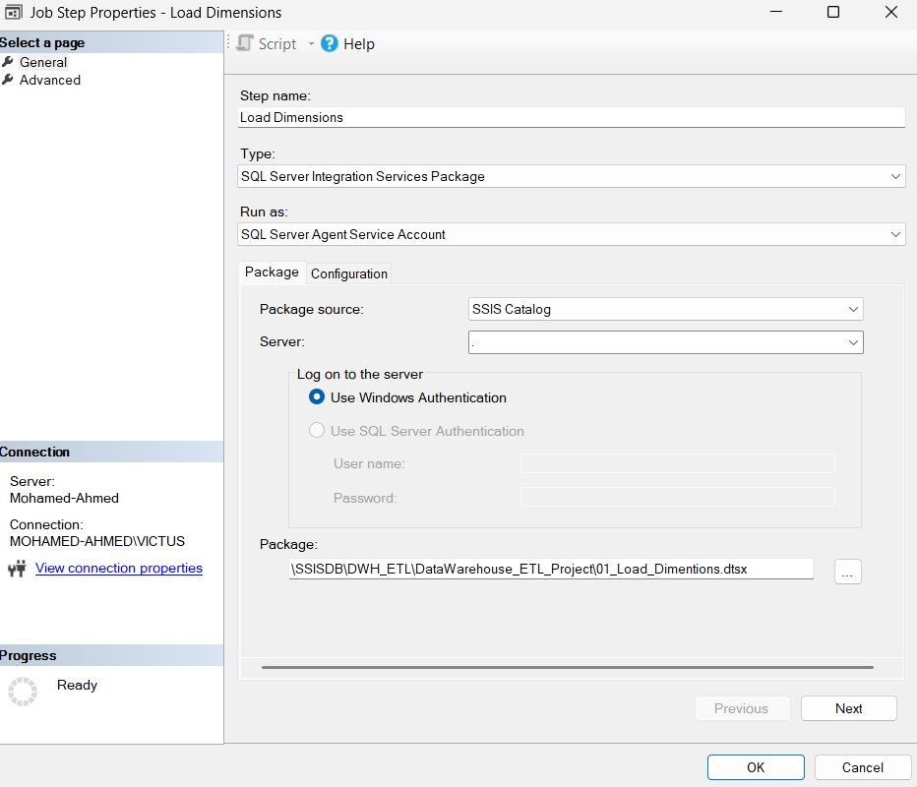  Fig. 6.1.3 | 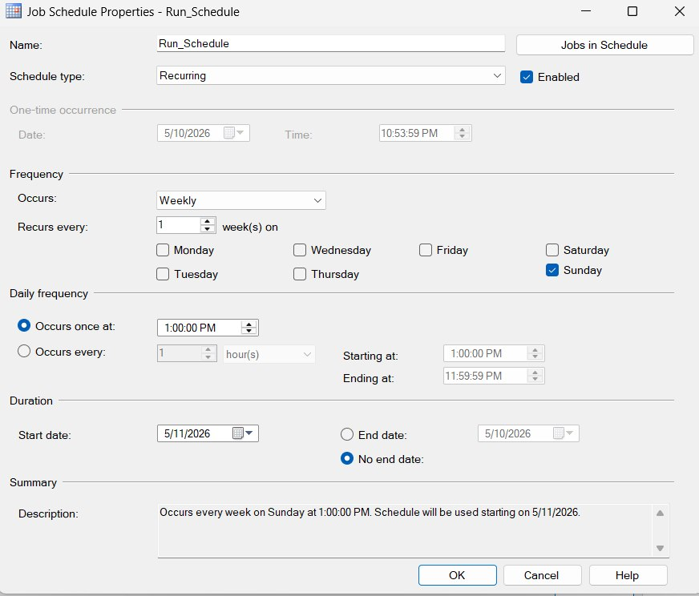  Fig. 6.1.4
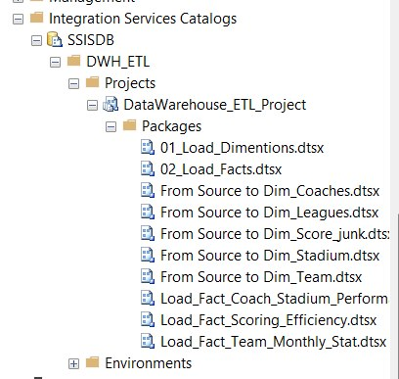
Fig. 6.1.5

6.2. After First Run Screenshots
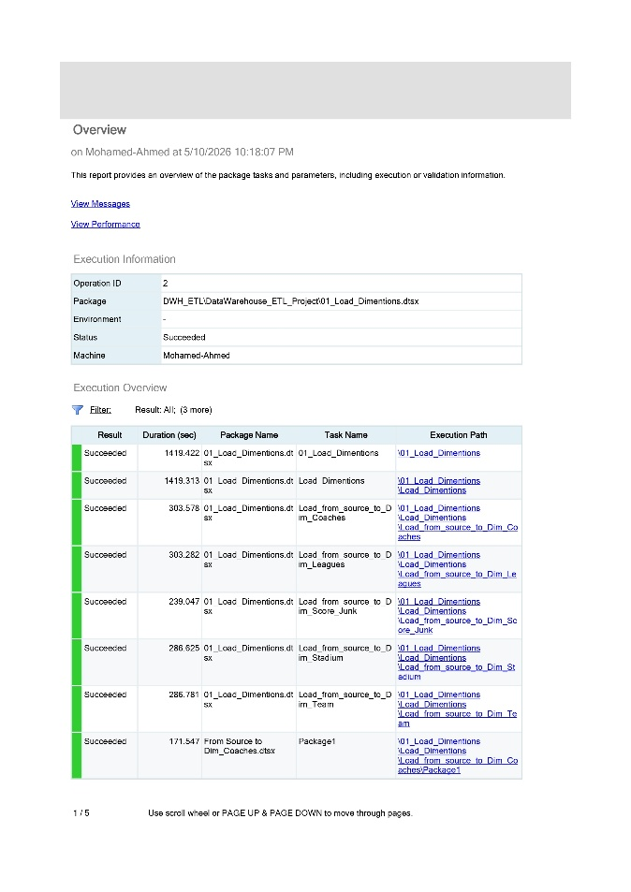  Fig. 6.2.1 | 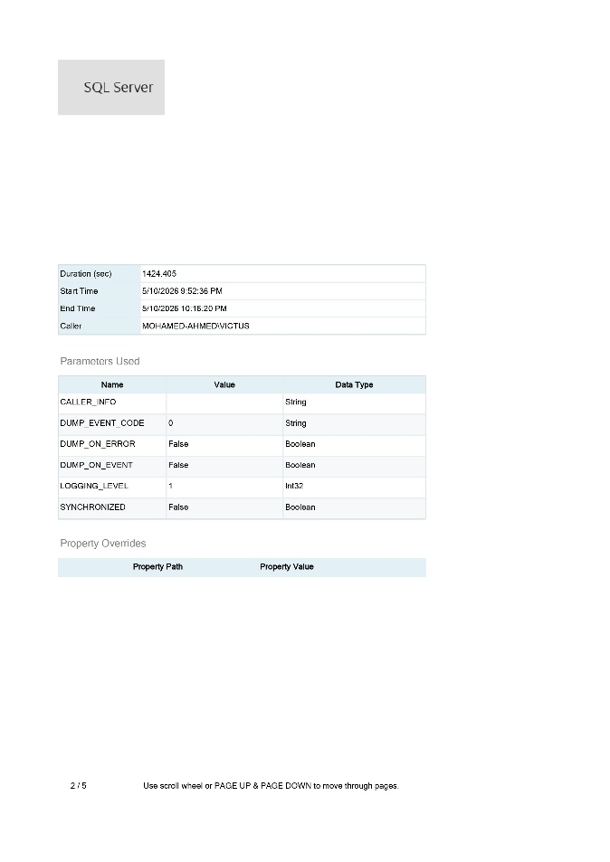  Fig. 6.2.2
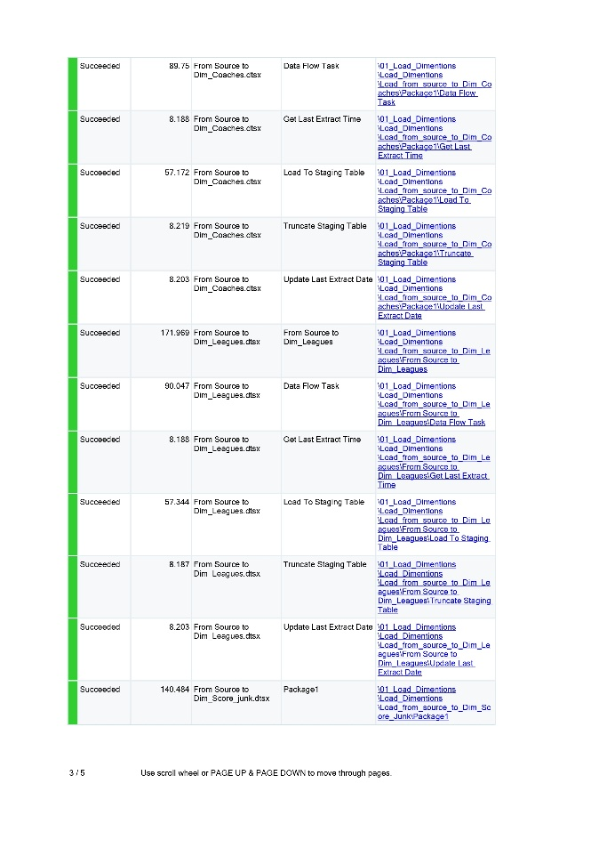  Fig. 6.2.3 | 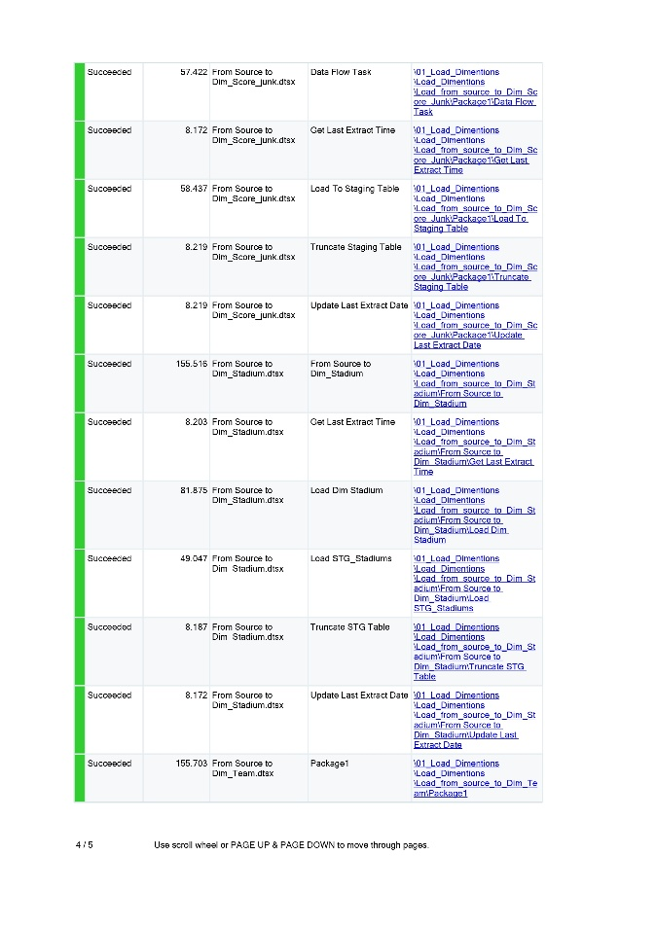  Fig. 6.2.4

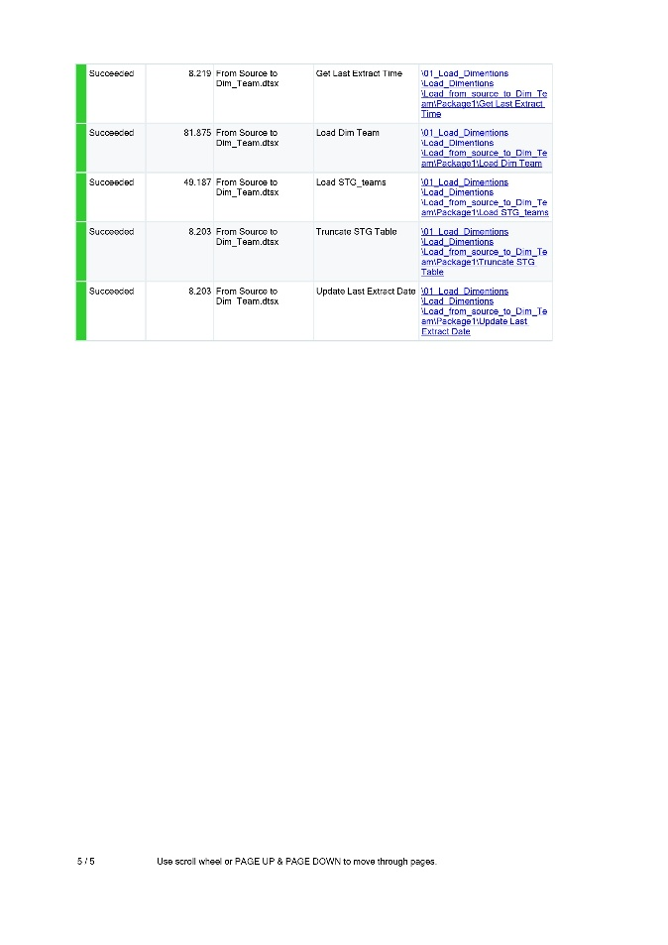
Fig. 6.2.5

6.3. After Second Run Screenshots
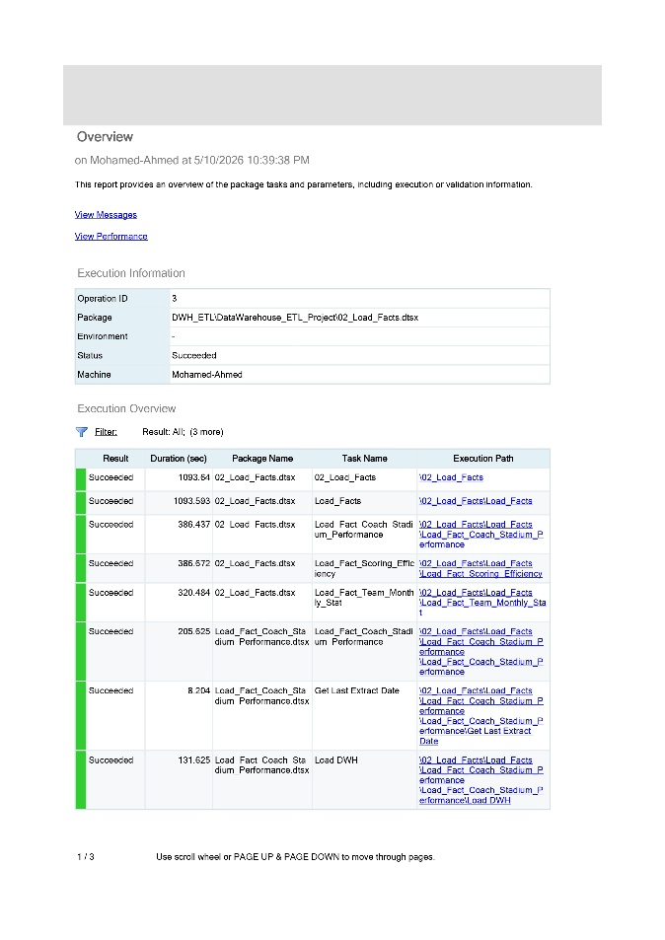  Fig. 6.3.1 | 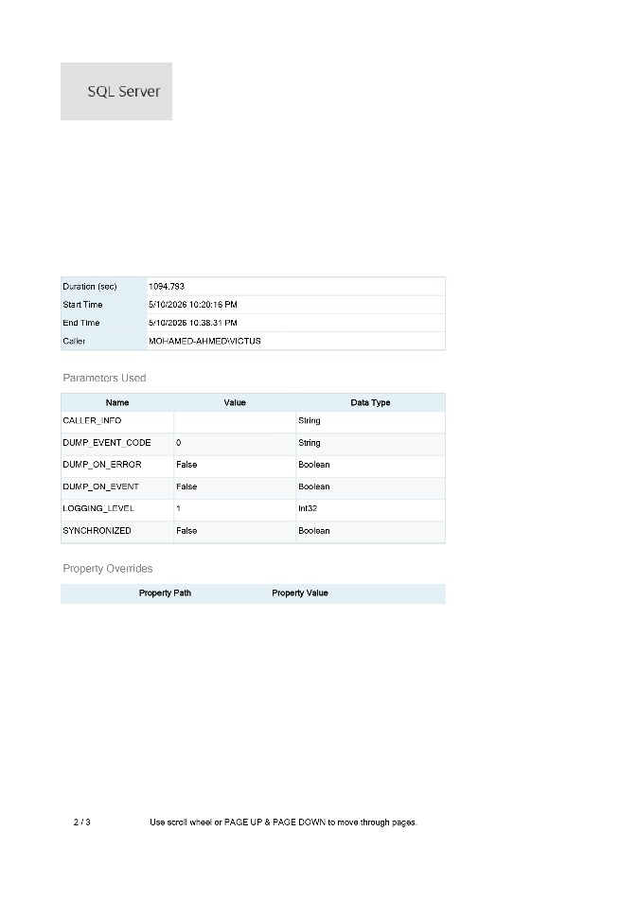  Fig. 6.3.2
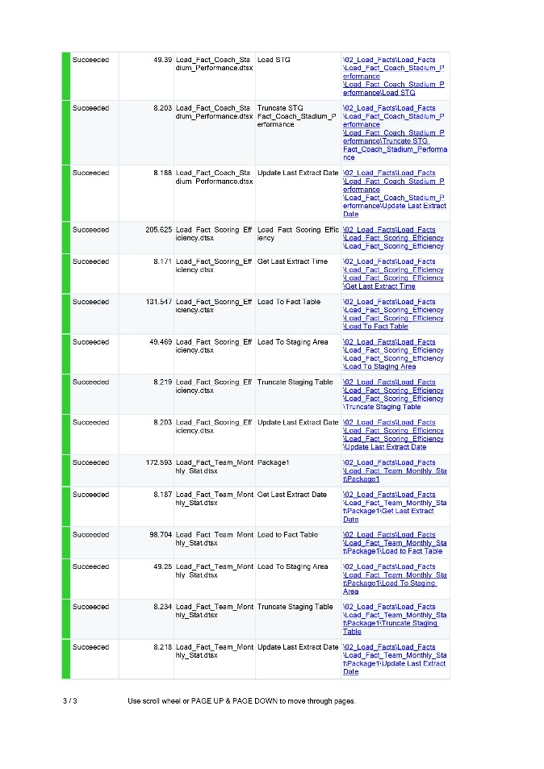
Fig. 6.3.3

7. Queries & Insights
This section presents analytical SQL queries used to generate insights from the warehouse.

7.1. Team Performance Analysis
This query identifies the strongest teams based on total points, wins, draws, and losses across all seasons.
SELECT  T.Name AS Team_Name,  SUM(F.Points_total) AS Total_Points,  SUM(F.Total_wins_count) AS Total_Wins,  SUM(F.Draw_count) AS Total_Draws,  SUM(F.Loss_count) AS Total_Losses  FROM DWH.Fact_Team_Monthly_Stat F  JOIN DWH.Dim_Team T ON F.Team_key = T.Team_key  GROUP BY T.Name; | 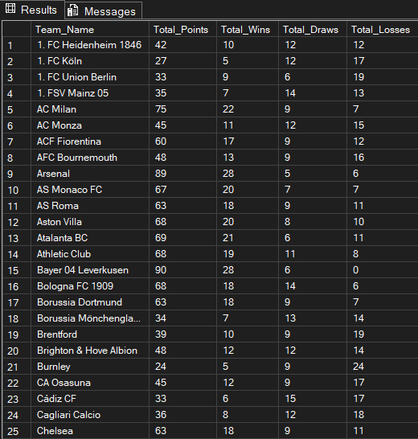

7.2. Goals & Offensive Performance
Teams with high goal differences generally maintained stronger attacking and defensive balance.
SELECT  T.Name AS Team_Name,  SUM(F.Goals_count) AS Total_Goals_Scored,  SUM(F.Goals_conceded) AS Total_Goals_Conceded,  SUM(F.Goal_difference) AS Total_Goal_Difference  FROM DWH.Fact_Team_Monthly_Stat F  JOIN DWH.Dim_Team T ON F.Team_key = T.Team_key  GROUP BY T.Name; | 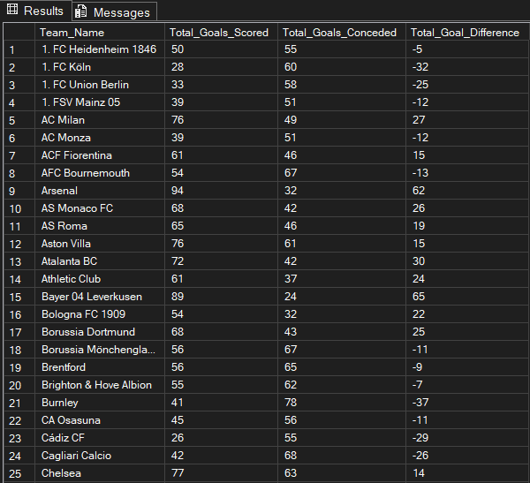

7.3. Team Efficiency Metrics
This query measures team consistency and efficiency using win percentage and average points per match.
SELECT  T.Name AS Team_Name,  SUM(F.Total_matches_played) AS Matches_Played,  (CAST(SUM(F.Total_wins_count) AS FLOAT) / NULLIF(SUM(F.Total_matches_played), 0)) * 100 AS Win_Rate,  CAST(SUM(F.Points_total) AS FLOAT) / NULLIF(SUM(F.Total_matches_played), 0) AS Avg_Points_Per_Match  FROM DWH.Fact_Team_Monthly_Stat F  JOIN DWH.Dim_Team T ON F.Team_key = T.Team_key  GROUP BY T.Name; | 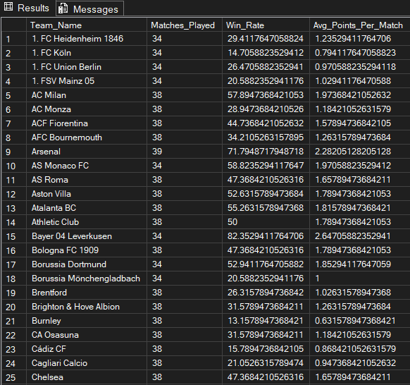

7.4. League Performance Analysis
This query compares leagues based on total scoring activity and match competitiveness.
SELECT  L.Name AS League_Name,  SUM(F.Goals_count) AS Total_League_Goals,  CAST(SUM(F.Goals_count) AS FLOAT) / SUM(F.Total_matches_played) AS Avg_Goals_Per_Match,  SUM(F.Total_matches_played) AS Total_League_Matches  FROM DWH.Fact_Team_Monthly_Stat F  JOIN DWH.Dim_League L ON F.League_key = L.League_key  GROUP BY L.Name; | 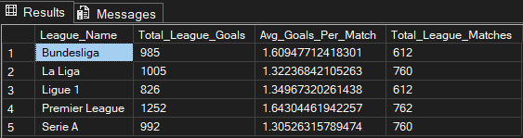

7.5. Home Advantage Analysis
The results show how much playing at home impacts winning probability in each league.
SELECT  L.Name AS League_Name,  CAST(SUM(F.Home_wins_count) AS FLOAT) / NULLIF(SUM(F.Total_wins_count), 0) AS Home_Advantage_Ratio  FROM DWH.Fact_Team_Monthly_Stat F  JOIN DWH.Dim_League L ON F.League_key = L.League_key  GROUP BY L.Name; | 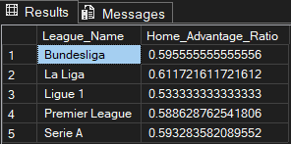

7.6. First Half vs Second Half Goals
This query analyzes whether teams perform better offensively during the first or second half.
SELECT  T.Name AS Team_Name,  SUM(F.Goals_1st_half) AS Total_1st_Half_Goals,  SUM(F.Goals_2nd_half) AS Total_2nd_Half_Goals  FROM DWH.Fact_Scoring_Efficiency F  JOIN DWH.Dim_Team T ON F.Team_key = T.Team_key  GROUP BY T.Name; | 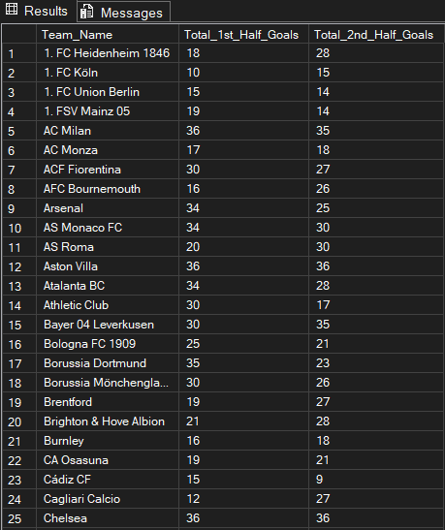

7.7. Comeback & Clean Sheet Analysis
Teams with higher comeback wins and clean sheets demonstrated strong mentality and defensive stability.
SELECT  T.Name AS Team_Name,  COUNT(CASE WHEN J.Is_comeback_win = 1 THEN 1 END) AS Comeback_Count,  COUNT(CASE WHEN J.Is_clean_sheet = 1 THEN 1 END) AS Clean_Sheet_Count  FROM DWH.Fact_Scoring_Efficiency F  JOIN DWH.Dim_Team T ON F.Team_key = T.Team_key  JOIN DWH.Dim_Scoring_Junk J ON F.Scoring_junk_key = J.Scoring_junk_key  GROUP BY T.Name; | 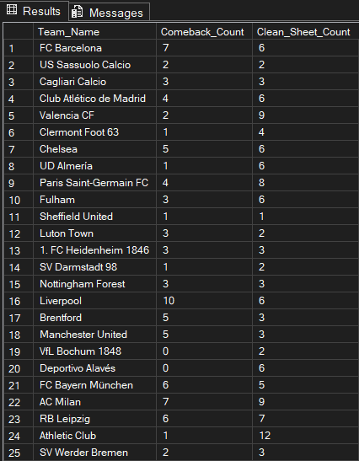

7.8. Coach Performance Analysis
This query evaluates coach effectiveness using win rate and average points earned.
SELECT  C.Name AS Coach_Name,  (CAST(COUNT(CASE WHEN F.Result_type = 'W' THEN 1 END) AS FLOAT) / COUNT(*)) * 100 AS Coach_Win_Rate,  AVG(CAST(F.Points_earned AS FLOAT)) AS Coach_Points_Per_Match  FROM DWH.Fact_Coach_Stadium_Performance F  JOIN DWH.Dim_Coach C ON F.Coach_key = C.Coach_key  GROUP BY C.Name; | 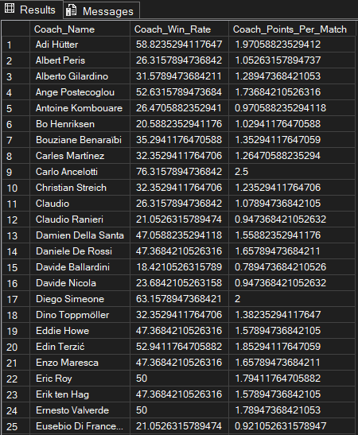

7.9. Stadium Performance Analysis
Certain stadiums provided a stronger home advantage and positively influenced team performance.
SELECT  S.Name AS Stadium_Name,  (CAST(COUNT(CASE WHEN F.Result_type = 'W' AND F.Is_home_coach = 1 THEN 1 END) AS FLOAT) /  NULLIF(COUNT(CASE WHEN F.Is_home_coach = 1 THEN 1 END), 0)) * 100 AS Home_Stadium_Win_Rate  FROM DWH.Fact_Coach_Stadium_Performance F  JOIN DWH.Dim_Stadium S ON F.Stadium_key = S.Stadium_key  GROUP BY S.Name; | 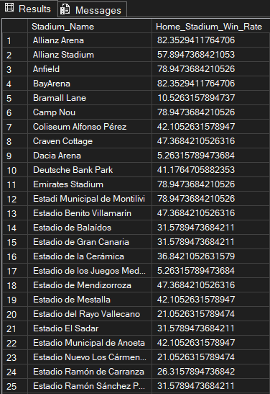

7.10. Monthly Performance Trend
This query tracks seasonal momentum and monthly performance fluctuations for each team.
SELECT  T.Name AS Team_Name,  D.MonthName,  SUM(F.Goals_count) AS Monthly_Goals,  SUM(F.Points_total) AS Monthly_Points  FROM DWH.Fact_Team_Monthly_Stat F  JOIN DWH.Dim_Team T ON F.Team_key = T.Team_key  JOIN DWH.Dim_Date D ON F.Month_key = D.DateKey  GROUP BY T.Name, D.MonthName, D.Month  ORDER BY T.Name, D.Month; | 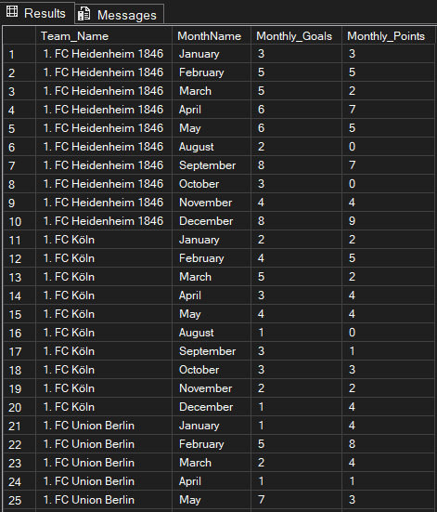

7.11. Second Half Specialist Teams
Some teams perform significantly better during the second half of matches.
SELECT  T.Name AS Team_Name,  SUM(F.Goals_1st_half) AS Total_1st_Half,  SUM(F.Goals_2nd_half) AS Total_2nd_Half,  COUNT(CASE WHEN J.Is_second_half_specialist = 1 THEN 1 END) AS Specialist_Match_Count  FROM DWH.Fact_Scoring_Efficiency F  JOIN DWH.Dim_Team T ON F.Team_key = T.Team_key  JOIN DWH.Dim_Scoring_Junk J ON F.Scoring_junk_key = J.Scoring_junk_key  GROUP BY T.Name  ORDER BY Specialist_Match_Count DESC; | 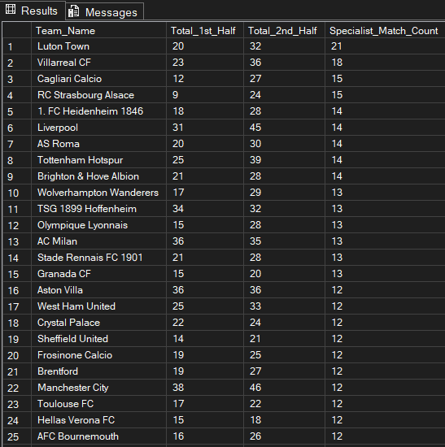

7.12. Coach Impact Score
This query evaluates coach performance against different opponents and tactical matchups.
SELECT  C.Name AS Coach_Name,  OC.Name AS Opponent_Coach_Name,  COUNT(*) AS Matches_Played,  SUM(F.Points_earned) AS Points_Gained_In_Matchup  FROM DWH.Fact_Coach_Stadium_Performance F  JOIN DWH.Dim_Coach C ON F.Coach_key = C.Coach_key  JOIN DWH.Dim_Coach OC ON F.Opponent_coach_key = OC.Coach_key  GROUP BY C.Name, OC.Name  ORDER BY Points_Gained_In_Matchup DESC; | 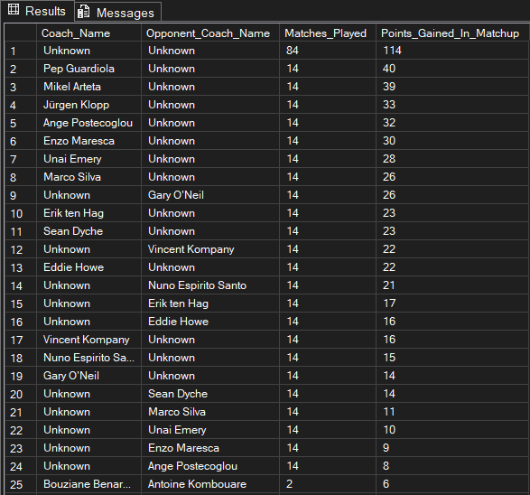

7.13. Stadium Capacity Impact
Larger stadiums may positively influence team morale and overall performance.
SELECT  S.Name AS Stadium_Name,  S.Capacity,  AVG(CAST(F.Points_earned AS FLOAT)) AS Avg_Points_At_Venue  FROM DWH.Fact_Coach_Stadium_Performance F  JOIN DWH.Dim_Stadium S ON F.Stadium_key = S.Stadium_key  GROUP BY S.Name, S.Capacity  ORDER BY Avg_Points_At_Venue DESC; | 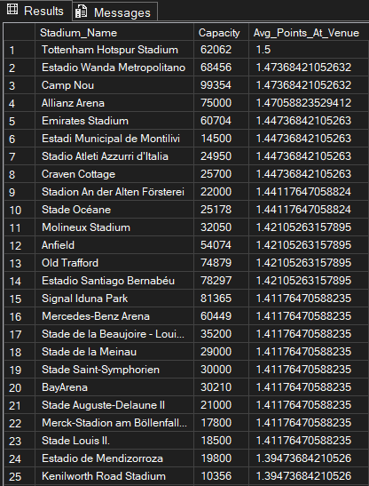

7.14. Average Goals per Match by League
This query identifies high-scoring leagues and offensive playing styles.
SELECT  L.Name AS League_Name,  F.Season_key,  AVG(CAST(F.Goals_total AS FLOAT)) AS Avg_Goals_Per_Match  FROM DWH.Fact_Scoring_Efficiency F  JOIN DWH.Dim_League L ON F.League_key = L.League_key  GROUP BY L.Name, F.Season_key  ORDER BY Avg_Goals_Per_Match DESC; | 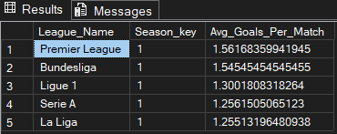

7.15. Competitive Balance Analysis
Lower volatility indicates more stable and balanced team performance across the season.
SELECT  T.Name AS Team_Name,  L.Name AS League_Name,  STDEV(F.Points_total) AS Points_Volatility,  AVG(F.Points_total) AS Average_Monthly_Points  FROM DWH.Fact_Team_Monthly_Stat F  JOIN DWH.Dim_Team T ON F.Team_key = T.Team_key  JOIN DWH.Dim_League L ON F.League_key = L.League_key  GROUP BY T.Name, L.Name  ORDER BY Points_Volatility ASC; | 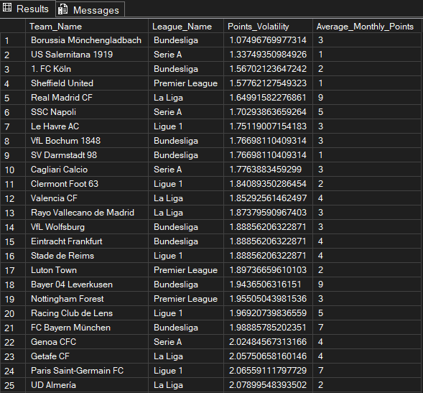

7.16. Stadium Tier Performance Analysis
Teams playing in larger stadiums often achieve better attacking statistics and point averages.
SELECT  CASE  WHEN S.Capacity >= 50000 THEN 'Elite (50k+)'  WHEN S.Capacity >= 30000 THEN 'Large (30k-50k)'  ELSE 'Medium/Small (<30k)'  END AS Stadium_Tier,  AVG(CAST(F.Points_earned AS FLOAT)) AS Avg_Points_Per_Match,  SUM(F.Goals_scored) AS Total_Goals_At_Tier  FROM DWH.Fact_Coach_Stadium_Performance F  JOIN DWH.Dim_Stadium S ON F.Stadium_key = S.Stadium_key  GROUP BY  CASE  WHEN S.Capacity >= 50000 THEN 'Elite (50k+)'  WHEN S.Capacity >= 30000 THEN 'Large (30k-50k)'  ELSE 'Medium/Small (<30k)'  END; | 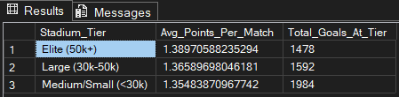

7.17. Second Half Goal Ratio Analysis
Teams with high second-half goal ratios usually demonstrate strong fitness and tactical adaptability.
SELECT  T.Name AS Team_Name,  SUM(F.Goals_1st_half) AS FH_Goals,  SUM(F.Goals_2nd_half) AS SH_Goals,  CAST(SUM(F.Goals_2nd_half) AS FLOAT) / NULLIF(SUM(F.Goals_total), 0) AS SH_Goal_Ratio  FROM DWH.Fact_Scoring_Efficiency F  JOIN DWH.Dim_Team T ON F.Team_key = T.Team_key  GROUP BY T.Name  HAVING CAST(SUM(F.Goals_2nd_half) AS FLOAT) / NULLIF(SUM(F.Goals_total), 0) > 0.6  ORDER BY SH_Goal_Ratio DESC; | 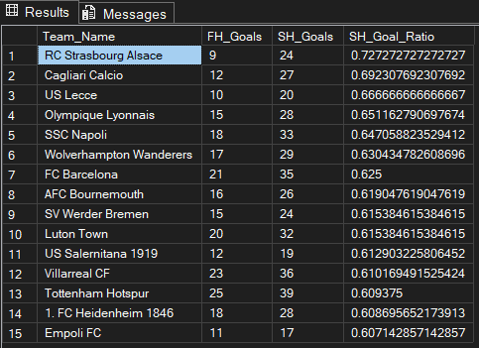

7.18. Away Match Coach Analysis
This query identifies coaches who maintain strong performance in away matches.
SELECT  C.Name AS Coach_Name,  COUNT(F.Fact_performance_key) AS Away_Matches,  AVG(CAST(F.Points_earned AS FLOAT)) AS Avg_Away_Points,  SUM(SE.Goals_2nd_half) AS Total_SH_Goals_Away  FROM DWH.Fact_Coach_Stadium_Performance F  JOIN DWH.Dim_Coach C ON F.Coach_key = C.Coach_key  JOIN DWH.Fact_Scoring_Efficiency SE ON F.Team_key = SE.Team_key  AND F.Date_key = SE.Date_key  WHERE F.Is_home_coach = 0  GROUP BY C.Name  ORDER BY Avg_Away_Points DESC; | 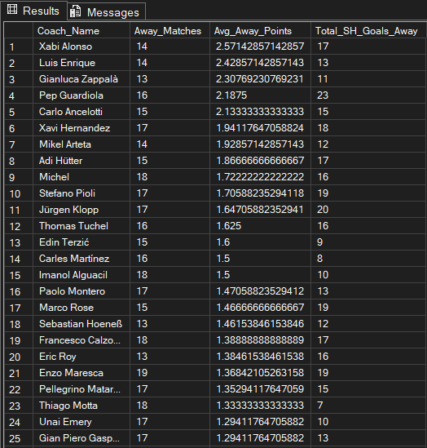

7.19. Lead Blowing Analysis
This query analyzes tactical weaknesses and defensive instability after leading at halftime.
SELECT  C.Name AS Coach_Name,  COUNT(F.Fact_performance_key) AS Matches_Led_At_HT,  COUNT(CASE WHEN J.Is_lead_blown = 1 THEN 1 END) AS Leads_Blown,  (CAST(COUNT(CASE WHEN J.Is_lead_blown = 1 THEN 1 END) AS FLOAT) / COUNT(*)) * 100 AS Lead_Blowing_Rate  FROM DWH.Fact_Coach_Stadium_Performance F  JOIN DWH.Dim_Coach C ON F.Coach_key = C.Coach_key  JOIN DWH.Fact_Scoring_Efficiency SE ON F.Team_key = SE.Team_key AND F.Date_key = SE.Date_key  JOIN DWH.Dim_Scoring_Junk J ON SE.Scoring_junk_key = J.Scoring_junk_key  GROUP BY C.Name  ORDER BY Lead_Blowing_Rate DESC; | 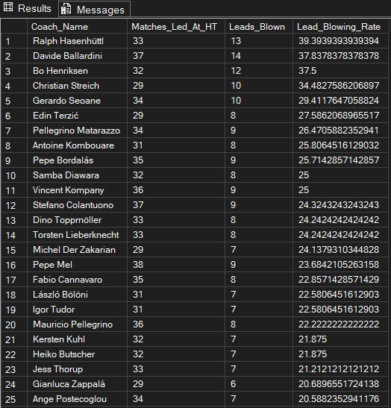

8. Power BI Dashboard (Bonus)
An interactive dashboard was developed using Microsoft Power BI to visualize and analyze the football Data Warehouse data.
The dashboard provides dynamic insights into team performance, league statistics, coach analysis, scoring efficiency, and stadium performance across multiple seasons.

8.1. Dashboard Data Source
The dashboard is connected directly to the European_Football_Leagues_DWH database and retrieves data from:
- Fact_Team_Monthly_Stat
- All related dimension tables

8.2. Dashboard Screenshot
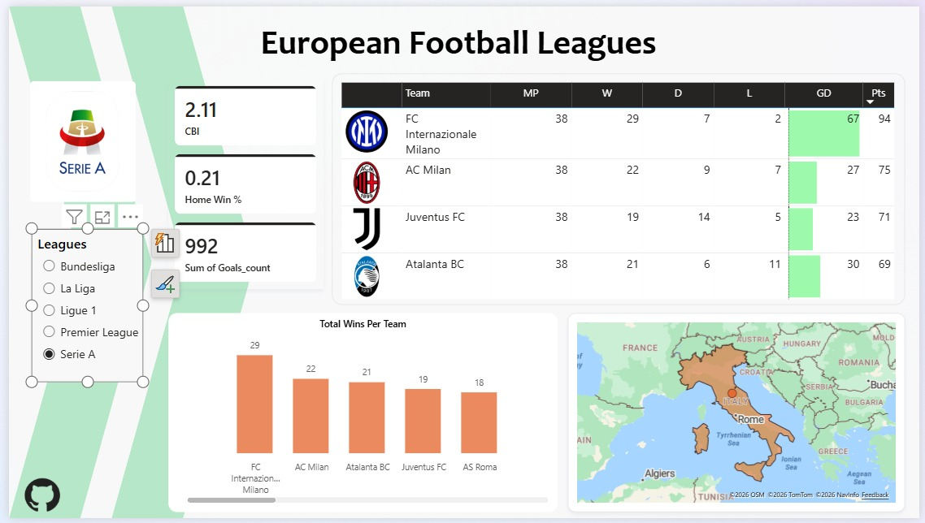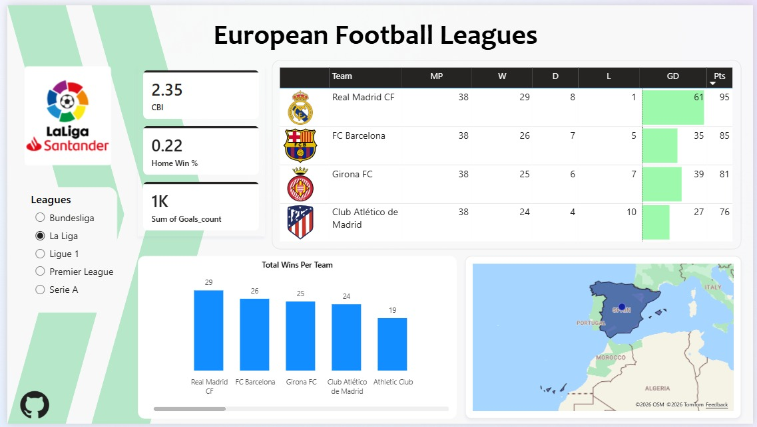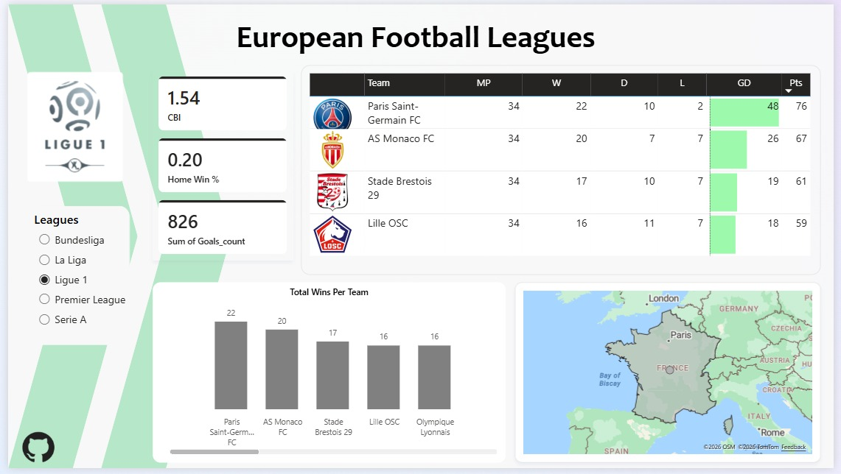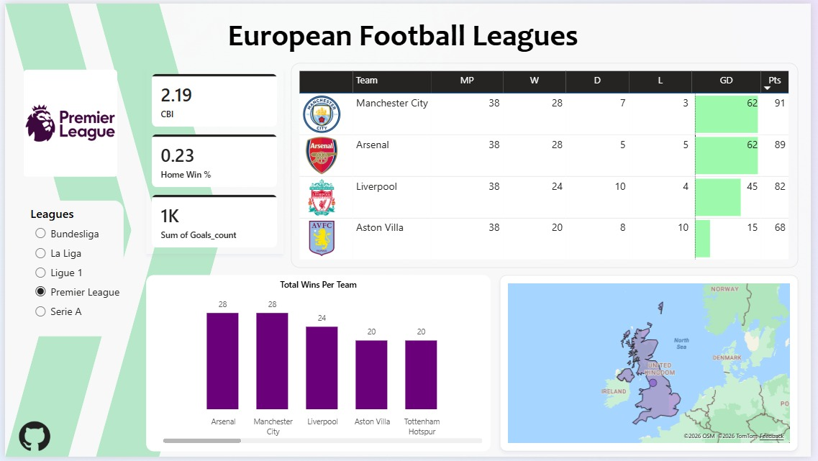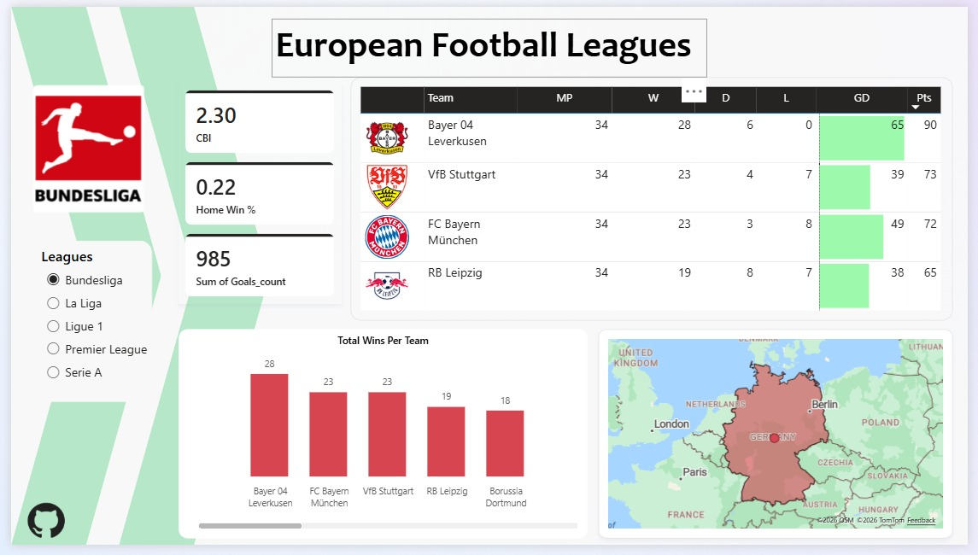

9. Conclusion
This project successfully designed and implemented a complete Football Data Warehouse solution using SQL Server and SSIS.
The system integrates data from multiple operational tables into a centralized analytical warehouse optimized for reporting and business intelligence.
The project included:
- Source database design
- Staging area implementation
- Dimensional modeling using Star Schema
- ETL pipeline development
- KPI generation
- Analytical SQL queries
- Power BI dashboard
The warehouse supports advanced football analytics including team performance, scoring efficiency, coach impact analysis, and stadium performance insights.
The implementation of incremental loading and dimensional modeling improved scalability, query performance, and reporting efficiency.
Future Enhancements
Potential future improvements include:
- Real-time streaming data integration
- Machine learning prediction models
- Player-level analytics
- Advanced Power BI dashboards
- Automated alert systems
- Cloud-based warehouse deployment

